S-100 – Part 8

Imagery and Gridded Data

Contents
8-1 Scope 1
8-2 Conformance 1
8-3 Normative references 1
8-4 Symbols and abbreviated terms 2
8-5 Imagery and Gridded Data Framework 3
8-5.1 Framework structure 3
8-5.2 Abstract Level 5
8-5.3 Content Model Level 5
8-5.3.1 Metadata 7
8-5.3.2 Encoding 8
8-6 Imagery and Gridded Data Spatial Schema 9
8-6.1 Coverages 9
8-6.2 Point Sets, Grids and TINs 9
8-6.2.1 Point Sets 9
8-6.2.2 Grid Types 10
8-6.2.3 Rectangular grids and irregularly shaped grids 11
8-6.2.4 Simple and tiled grids 12
8-6.2.5 Regular and variable cell sizes 13
8-6.2.6 Grids in 2 or 3 dimensions 15
8-6.2.7 TIN 16
8-6.3 Data Set Structure 17
8-6.3.1 Data Set Class 19
8-6.3.2 S100_Discovery Metadata Module 19
8-6.3.3 S100_Transmittal 19
8-6.3.4 S100_IG_Collection 19
8-6.3.5 S100_Collection Metadata Module 19
8-6.3.6 S100_Structure Metadata Module 19
8-6.3.7 S100_Acquisition Metadata Module 20
8-6.3.8 S100_Quality Metadata Module 20
8-6.3.9 S100_IG_Data Type 20
8-6.3.10 Components 20
8-6.3.11 S100_Tiling Scheme 20
8-7 Tiling Scheme 20
8-7.1 Spatial Schema 20
8-7.1.1 S100_Point Set Spatial Model 21
8-7.1.2 S100_PointCoverage Spatial Model 22
8-7.1.3 S100_TIN Coverage Spatial Model 24
8-7.1.4 S100_Grid Coverage Spatial Model 28
8-7.2 Rectified or Georeferencable Grids 31
8-8 Data Spatial Referencing 33
8-8.1 Gridded Data Spatial Referencing 33
8-8.1.1 Georectified 33
8-8.1.2 Ungeorectified 34
8-8.1.3 Georeferenced 34
8-8.1.4 Georeferencable 35
8-8.2 Point Set Data and TIN Triangle Vertex Spatial Referencing 35
8-8.3 Imagery and Gridded Data Metadata 35
8-8.4 Quality 37
8-9 Imagery and Gridded Data Portrayal 37
8-10 Imagery and Gridded Data Encoding 37
8-11 Spatial Schema for Point Sets 37
8-11.1 Gridded data 37
8-11.2 Scanned Image 40
8-11.3 Variable Cell Size Grid 42
8-11.4 Feature Oriented Image 45
Appendix 8-A Abstract Test Suite 47
Appendix 8-B Terminology 49
Appendix 8-C Quality Model for Imagery and Gridded Data 50
Appendix 8-D Metadata 51
Appendix 8-E Portrayal of Imagery and Gridded Data 55
Appendix 8-F Feature Oriented Images 58

Scope
S-100 has the capability to support imagery, gridded and several other types of coverage data as an integral component. Imagery and gridded data are common forms of geographic data and there exist many external standards designed to handle such data. An image is a particular type of gridded data structure that can be visualized. Since almost all sets of gridded data can be portrayed to form an image, the term image is very broad. S-100 must not preclude compatibility with external sources of data.

Hydrographic soundings are by their nature a set of measured data points. These data points can be represented in a grid structure in several different ways, including elevation models using a regular grid spacing, and irregular grids with variable size cells. They can also be represented as Triangular Irregular Networks (TIN triangles) or as point sets. Images are also of great importance for hydrographic data. This includes images from sensors such as aerial photography or LIDAR, photographs that can be associated with vector based feature oriented data and products based on scanned paper charts, commonly known as “Raster Charts”. All of these applications of imagery and gridded data are covered by this component of S-100. This imagery and gridded data component aligns with the international standards for imagery and gridded data in order to support multiple sources of data and uses the common information structures based on the ISO TC/211 19100 suite of standards that allows imagery, gridded and coverage data to be combined with boundary defined (vector based) data and other types of data.

The applicable hierarchical terminology is standardized in the ISO 19100 suite of standards. A set of data that describes a set of attribute values distributed over an area is called a coverage of which there are many different types, but the most common structure is a grid. Presently, S-100 only addresses grid based coverages, point set coverages, and TIN coverages.

This Part of S-100 is based on ISO 19129 – “Geographic information – Imagery, Gridded and Coverage Data Framework”. However, it is more specific than the ISO 19100 suite of standards and defines specific grid organizations to be used for hydrographic data and images associated with hydrographic data. Both simple grids and complex multidimensional grids are defined, as well as point sets and TINs. This Part identifies the content model for coverage data for use in hydrographic applications, including imagery as a type of gridded data. It describes the organization, type of grid or other coverage structure and associated metadata and spatial referencing for georeferenced data. The encoding and portrayal of imagery, gridded and coverage data is external to this part of S-100, although the manner by which encoding and portrayal makes use of the identified content models are identified.

Conformance
The Abstract Test Suite presented in Appendix 8-A indicates how a coverage based product complies with the content models established in this document.

Any product addressing imagery, gridded or coverage data, claiming conformance with S-100 shall pass the requirements described in the abstract test suite, presented in Appendix 8-A.

Normative references
The following external normative documents contain provisions, which through reference in this text constitute provisions of this standard. All of the relevant information from these base standards that applies to S-100 has been included in this standard. Access to these base standards is required only if one wishes to develop generic applications that encompass and exceed the scope of S-100. Other components of S-100 may include information extracted from these and other external standards.

ISO 19103, Geographic information — Conceptual schema language
ISO 19107, Geographic information — Spatial schema
ISO 19108, Geographic information — Temporal schema
ISO 19111, Geographic information — Spatial referencing by coordinates
ISO 19113, Geographic information — Quality principles
ISO 19114, Geographic information — Quality evaluation procedures
ISO 19115, Geographic information — Metadata
ISO 19115-2, Geographic information — Metadata - Part 2 Extensions for imagery and gridded data
ISO 19117, Geographic information — Portrayal
ISO 19118, Geographic information — Encoding
ISO 19123, Geographic information — Schema for coverage geometry and functions
ISO 19129, Geographic information — Imagery, Gridded and Coverage Data Framework
ISO 19130, Geographic information — Sensor and data models for imagery and gridded data
ISO/IEC 12087-5:1998 - Computer graphics and image processing -- Image Processing and Interchange (IPI) - Functional Specification - Basic Image Interchange Format (BIIF)
ISO/IEC 15444-1:2004 - Information Technology -- JPEG 2000 image coding system
IHO S-52 Specifications for Chart Content and Display Aspects of ECDIS
IHO S-61 Product Specification for Raster Navigational Charts (RNC)
American National Standard T1.523-2001 - Telecommunications Glossary 2000.

Symbols and abbreviated terms
For the purposes of this component of S-100, the following symbols and abbreviated terms apply.
TIN Triangulated Irregular Network

Imagery and Gridded Data Framework

Framework structure
The framework for Imagery, Gridded and Coverage data used in this Part of S-100 is derived from ISO 19129 Imagery, Gridded and Coverage data Framework. Only a subset of the framework defined in the ISO standard is required in S-100. The framework as described in ISO can support both georeferenced and georeferenceable data. This component of S100 is limited to georeferenced data although it can easily be extended in the future to address georeferenceable data such as sensor data.

The framework identifies how the various elements of a coverage data set fit together. The framework provides a common structure that establishes an underlying compatibility between different sets of coverage data. The common framework established in ISO 19129 fosters a convergence at the "Content Model" level between different sets of imagery and gridded data expressed using different standards and also between the information holdings expressed using these standards. An underlying compatibility at the content model level for a broad range of imagery and gridded data allows for backward compatibility with existing standards. The content model describes information independent of the way in which it is stored, communicated or portrayed. This permits multiple encodings for the same content.

Gridded data, including imagery data, is fundamentally simple. It consists of a set of attribute values organized in a grid together with metadata to describe the meaning of the attribute values and spatial referencing information to position the data. Other coverage data is also simple. It also defines a set of points or triangles that drive a coverage function together with metadata. The metadata may contain identification information, quality information, such as the sensor from which the data was collected. The spatial referencing information contains information about how the set of attribute values is referenced to the earth. The spatial referencing information itself is expressed as metadata.
Auxiliary information, also expressed as metadata, may assist in portrayal or encoding, however the basic content may be portrayed in different ways or carried using different encoding mechanisms, so such auxiliary information is not a part of an imagery and gridded data content model. Figure 8-1 illustrates the simple structure of gridded data.

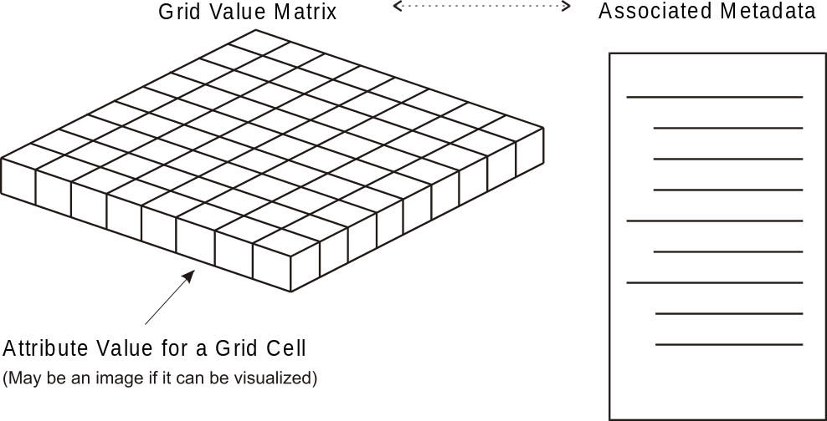
Figure 8-1 – Simple Structure of Gridded Data
(Showing the Relationship of Metadata to
a set of Gridded Data Represented in a Grid Value Matrix)

The ISO 19129 framework standard allows Imagery, Gridded and Coverage data to be described at several levels. These are an abstract level as addressed in ISO 19123 Geographic information - Schema for coverage geometry and functions, a content model level and an encoding level. The encoding level is independent from the content level. Multiple different encodings may carry the same content.

Most of the existing standards relating to imagery and gridded data describe data content in terms of its representation in an exchange format. The format defines data fields and describes the contents and meaning of these data fields. This implicitly defines the information content that can be carried by the exchange format. Defining the content in terms of its encoding binds the content to that single encoding format and makes data conversion very difficult.

The ISO 19100 suite of standards defines geographic information content in terms of an object oriented data model expressed in the Unified Modeling Language (UML). which allows the content to be encoded using different exchange formats or stored in a database irrespective of the exchange encoding. The following figure, corresponding to ISO 19129, presents the overall relationship between the elements of the framework.

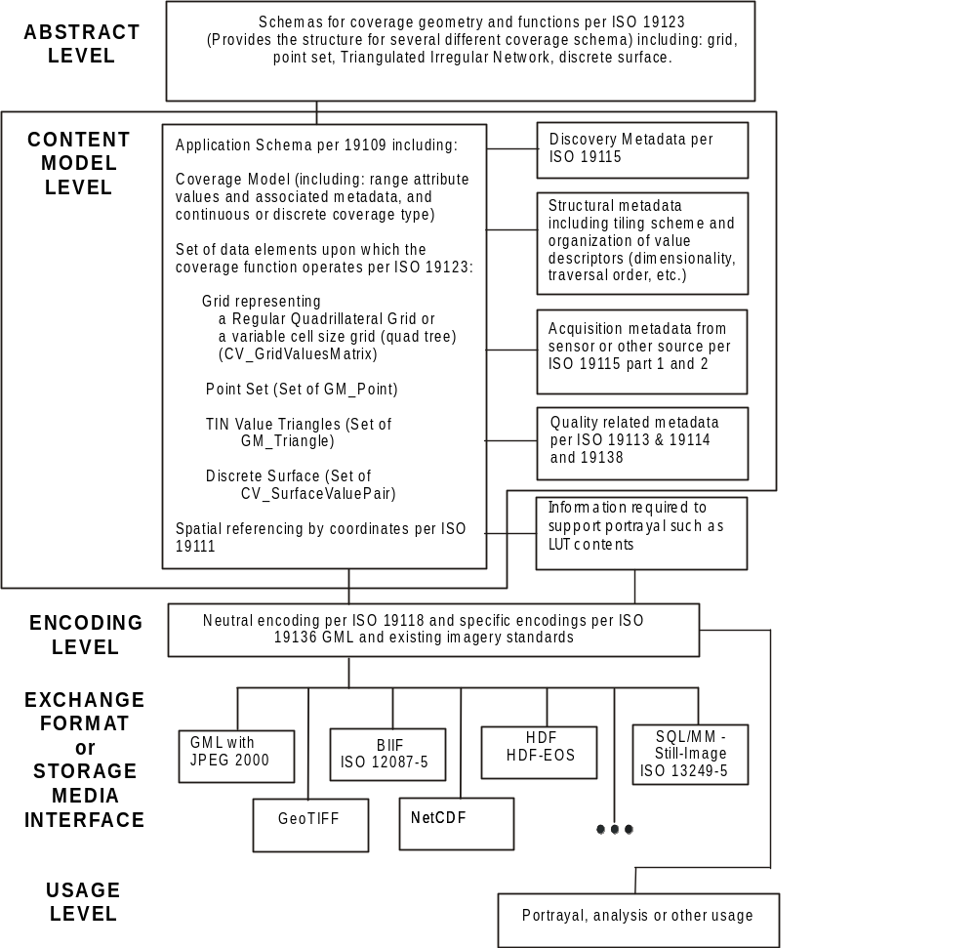
Figure 8-2 – Overall relationship between the elements of the framework

Abstract Level
The abstract level provides a generic structure for all types of coverage geometries including gridded data geometries and point set and TIN geometries. This abstract structure is defined in ISO 19123 – Geographic information – Schema for coverage geometry and functions. S-100 takes from ISO 19123 various types of grid structures including a rectangular grid, an irregularly shaped grid, a grid with variable cell sizes and a multi-dimensional grid. A tiled grid is actually a set of grids. S-100 also includes a point coverage and a TIN coverage derived from ISO 19123.

Content Model Level
The content model level describes the information content of a set of geographic information consisting of: the spatial schema, feature identification and associated metadata, where other aspects such as quality, geo-referencing, etc, is represented in the metadata. The content model does not include portrayal or encoding or the organization of the data to accommodate various storage or exchange media. Exchange metadata that describes the information about a data exchange is not part of the information defined by the content model.

The content model level consists of a set of predefined content structures, which serve as the core for various application schemas to be developed for imagery and gridded data. A small set of grids, with associated traversal orders are defined. This provides the spatial organization for gridded data. A point set structure and a TIN structure are also defined.

The feature model defined in ISO 19109 “Geographic information - Rules for application schema, applies to imagery and gridded data”. Although the conventional approach is to consider an image as a unique entity on its own, and to not consider a feature structure, it is proper to consider imagery, gridded and coverage data as feature oriented data. In the simplest form, an image or any set of gridded data can be considered as a single feature. For example, an entire satellite image could be considered as a single feature – the image. However, it is also possible to do feature extraction on an image, where sets of pixels are the geometric representation of a feature. Certain selected pixels could correspond to a bridge, and other pixels correspond to a rock. An application schema can contain a feature model, where the geometric component of the feature model consists of sets of geometric points corresponding to the picture elements (pixels) in a grid structure of an image. However, if a feature structure is associated with an image it is necessary to provide a method of linking feature IDs to individual pixels in the image. This can be done by carrying additional attributes in the grid value matrix, or by a pointer structure. For example, an image may be represented as a simple grid consisting of a set or rows and columns providing organization to a set of pixels. Each pixel contains attributional data such as the colour and light intensity seen at that point. Each pixel may also contain an additional attribute that indicates the feature ID associated with the pixel, so that the pixels corresponding to the image of a bridge are marked as the feature bridge, and those corresponding to a rock are marked as rock. Other more efficient structures may be defined to identify sets of pixels as corresponding to a given feature. This capability is particularly useful for adding intelligence to raster scanned image paper chart products, and for fusing S-100 vector data products with imagery and gridded data products.

The Content Model includes the spatial structure and the metadata. The encoding structure is separate but related. Systemic compression which allows for data compaction is part of the content model whereas stochastic compression which allows for data compression is not. An example of systemic compression is the removal of information that is known by the application to be not necessary. This would include areas over which there is no data (sub-tiling), and the removal of lower order bits of numeric data for lower precision numbers. A tiled grid exhibits systemic compression when tiles are only defined for areas where there is data. Systemic compression also exists in a variable size pixel structure where adjacent pixels of the same attribute value can be aggregated into a single larger pixel. Stochastic (statistical) compression removes redundant information that occurs randomly. For example, repeated bit patterns that can be compressed by an algorithm. The ZIP algorithm often used to compress files is an example of stochastic compression. Systemic compression relates to a particular type of image, whereas stochastic compression relates to a particular instance of an image. Both types of compression may be applied, but the stochastic compression is part of the encoding structure, whereas the systemic compression is part of the content model.
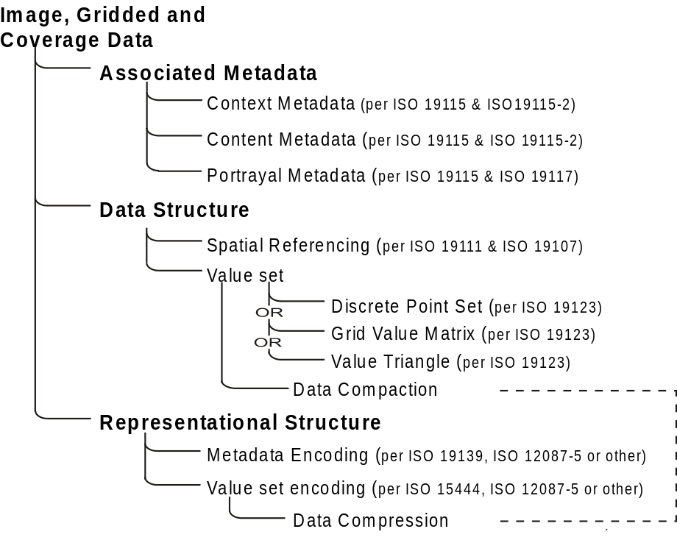
Figure 8-3 – Image and Gridded Data Structure
Figure 8-4 (below) presents the elements contained in a general content model for imagery gridded and coverage data. This is a subset of Figure 8-3 above, with the representational structure not shown, since it is not part of the content model. The mechanism for systemic compression is not directly shown because it relates to the structure of the Grid Value Matrix.

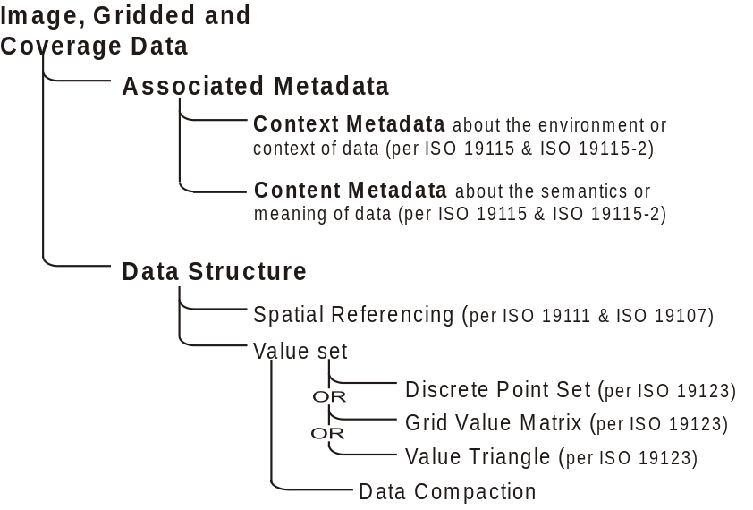

Figure 8-4 – General Imagery and Gridded Data Content Description

Metadata
The metadata elements that are used in imagery, gridded and coverage data are presented in Table 8-1. The table organizes the metadata elements according to whether the metadata relates to the description of the imagery, gridded or coverage data content, or to the environment in which it exists, or the representation of the data. Additional representational metadata may exist in an encoding format.
Table 8-1 — Metadata Elements
Type (Metadata Package) | Description | relationship
Metadata Elements (19115)
Metadata entity set information | metadata entity set information | Environment
Identification information | information to uniquely identify the data. Identification information includes information about the citation for the resource, an abstract, the purpose, credit, the status and points of contact | Environment
Constraint information | information concerning the restrictions placed on data | Environment
Data quality information | assessment of the quality of the data | Content
Maintenance information | information about the scope and frequency of updating data | Environment
Spatial representation information | information concerning the mechanisms used to represent spatial information | Content
Reference system information | the description of the spatial and temporal reference system(s) | Content
Content information | information identifying the feature catalogue | Content
Portrayal catalogue information | information identifying the portrayal catalogue | Representation
Distribution information | information about the distributor of, and options for obtaining, a resource | Environment
Metadata extension information | information about user specified extensions | Various
Application schema information | information about the application schema used to build a dataset | Content
Metadata Imagery Extensions per 19115-2
Content Information Imagery | additional information used to identify the content of coverage data | Content
Identification Information Imagery | information to uniquely identify the data, including extensions to describe references that apply to the data and entities to identify the components used to acquire the data. | Environment
Requirements Information Imagery | provides details specific to the tasking and planning associated with the collection of imagery and gridded data | Environment
Acquisition Information Imagery | information on the acquisition of imagery and gridded data
Data Quality Information Imagery | assessment of the quality of the imagery data | Content
Spatial Representation Information Imagery | additional information the mechanisms used to represent spatial information for imagery | Content
Metadata Datatypes
Extent information | metadata elements that describe the spatial and temporal extent - “geographicElement”, “temporalElement”, and “verticalElement | Content
Extent Information Imagery | defines additional attributes used to specify the location of the minimum and maximum vertical extent values within the dataset | Content
Citation and responsible party information | a standardized method (CI_Citation) for citing a resource (dataset, feature, source, publication, etc.), as well as information about the party responsible (CI_ResponsibleParty) for a resource | Environment

Encoding
The content model defines the structure to which an encoding rule may be applied. There are a large number of different encodings used for imagery, gridded and coverage data that provide encoding services for this class of information. Many of these encodings are well used standardized exchange formats. S-100 provides a common content model structure that can be encoded or stored using different encoding formats (e.g. Figure 8-2, GeoTIF).

Gridded data, including imagery, is among the simplest data structures for geographic information. However it is data intensive, i.e. there are a large number of picture elements or grid cells in a data set. There are two different kinds of information to encode, the grid value matrix elements (pixels, grid cells) and the metadata about them. These may be encoded in the same integrated standard, or as two separate linked sets of information. In addition most encoding rules for imagery and gridded data include stochastic compression rules to reduce the data volume of the grid value matrix element data.

There are already several ISO standards developed under ISO JTC1 Information Technology that address picture coding and imagery data applicable to the content model structures defined in this document. In particular there are the standards JTC1 SC29, Picture coding and JTC1 SC24 Computer Graphics and Image Processing. These standards should be used where applicable. A number of commercially defined standards or standards defined in other organizations can also be used. A survey of these standards is provided in ISO Technical Report 19121.

Hydrographic data may make use of several different encodings for imagery data. In particular two proprietary formats to handle raster-scanned paper chart data are in wide use. Either format may be used to carry the same scanned paper chart content conforming to a common content model. A different encoding may be appropriate for image data such as satellite imagery or LIDAR imagery. A third encoding may be appropriate for sonar data. All of these data sets would comply with the general content model structure and particular content models for their particular product specifications. Unique encodings are required for point set data and for TIN triangle data.

To promote compatible data exchange it is desirable to have a common neutral encoding format, even if that format is not optimal for the particular data set. There is no decision in the ISO standards regarding the appropriate neutral format-independent encoding because ISO is addressing a broad range of "information communities". A neutral encoding which may be used in S-100 consists of the use of an XML encoding to describe the metadata aspects of imagery and gridded data and an appropriate value element encoding mechanism taken from the ISO JTC1 SC29 standards on picture coding. In particular the ISO 15444-1 JPEG 2000 standard should be used together with XML/GML (ISO 19136) as a neutral encoding for gridded data. A more general encoding is the Hierachical Data Format (HDF version 5), which is object oriented and suitable for all types of coverage data, including point sets and TIN triangles. HDF 5 forms the basis of NetCDF, a popular format used for scientific data. Regardless of which format is used the content model must be the same so that the data can be converted from one format to another without loss.

Imagery and Gridded Data Spatial Schema

Coverages
A coverage associates positions within a bounded space to attribute values. A coverage is a subtype of feature; that is, it associates positions within a bounded space to the attribute values of the feature. A continuous coverage function associates a value to every position within the spatial temporal domain of the function. A discrete coverage function is only valid at specific positions within the domain. Geometric objects within the spatiotemporal domain drive the coverage function. A coverage function effectively acts as an interpolation function for the geometric objects within the spatiotemporal domain, which establishes a value within the range of the function for every position within the domain.

The geometric objects within the spatiotemporal domain are described in terms of direct positions. The geometric objects may exhaustively partition the spatiotemporal domain, and thereby form a tessellation such as a grid or a TIN. Point sets and other sets of non-continuous geometric objects do not form tessellations.

ISO 19107 defines a number of geometric objects (subtypes of the UML class GM_Object) to be used for the description of features. Some of these geometric objects can be used to define spatiotemporal domains for coverages. ISO 19123 defines additional subtypes of GM_Object that are specialised for the description of spatiotemporal domains. In addition, ISO 19108 defines TM_GeometricPrimitives that may also be used to define spatiotemporal domains of coverages.

The range of a coverage is a set of feature attribute values. The value set is represented as a collection of records with a common schema. For example, a value set might consist of temperature and depth measured at a given time over a bounded area of ocean. A coverage function may be used to evaluate a depth and temperature anywhere within the bounded area.

A discrete coverage has a spatiotemporal domain that consists of a finite collection of geometric objects and the direct positions contained in those geometric objects. A discrete coverage maps each geometric object to a single record of feature attribute values. A discrete coverage is thus a discrete or step function as opposed to a continuous coverage. For example assigning a feature code to each cell in a grid cell tesselation is a discrete coverage. Each grid cell is either associated or not associated with a particular feature.

A continuous coverage has a spatiotemporal domain that consists of a set of direct positions in a coordinate space. A continuous coverage maps direct positions to value records. In principle, a continuous coverage could consist of no more than a spatially bounded, but transfinite set of direct positions, and a mathematical function that relates direct position to feature attribute value.

The concept of coverages is described in this document to relate coverage functions to the set of geometric objects and the direct positions that drive the coverage functions. It is through the concept of coverages that one may relate the concept of features to a grid, a set of TIN triangles or a point set. This description has been adapted from ISO 19123. S-100 only addresses grids, TINs and point sets. To address other types of coverages see ISO 19123.

Point Sets, Grids and TINs

Point Sets
S-100 addresses only imagery and gridded data associated with grids and point sets. These two constructs establish the basic geometry elements used in this component of S-100.
A point set is a set of GM_Point objects in a bounded area. These point objects might each be associated with one or more features. They may also form a coverage and serve to drive a coverage function. Hydrographic soundings may be considered as a point set. For each point set value it is necessary to know the position of the point as well as any associated attribute value and associated feature reference. Attributes may be assigned to an entire point set as an aggregate as well as to individual points. This is common practise for hydrographic soundings where metadata may be associated with a sounding object that consists of a point set of individual soundings. Several point sets may be aggregated into one coverage. A simple point set with associated metadata is illustrated in Figure 8-5.

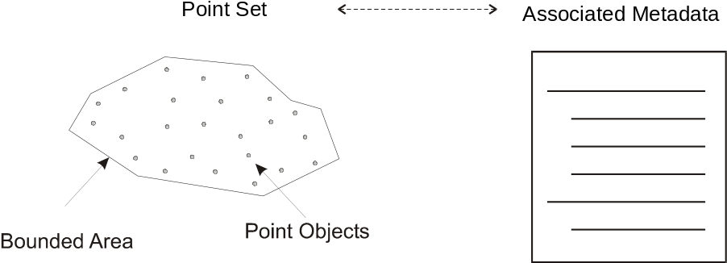
Figure 8-5 – Point Set with Associated Metadata

A Point Set is a set of 2, 3 or n dimensional points in space. A Point Set Coverage is a coverage function associated with point value pairs in 2 dimensions. That is, a coverage function is driven by a set of points (with X, Y position) together with a record of one or more values at that position.

Grid Types
A grid is a regular tessellation of a bounded space where two or more sets of curves in which the members of each set intersect the members of the other sets in a systematic way. The curves are called grid lines; the points at which they intersect are grid points, and the interstices between the grid lines are grid cells. A grid covers the entire bounded space. Grids form the basic geometry for a gridded data coverage. There are several different regular tessellations of a space that are all subtypes of the general concept of grid. Common to all grids is an implicit sequence or traversal order. There also exist a number of possible traversal orders for grids, some more useful than others in different situations. The location of a grid cell is defined implicitly by the regular grid organization and the traversal order. For example, in a rectangular grid each grid cell can be addressed by the row and column order of the grid. It is therefore not necessary to maintain the direct position of each grid cell. More complex grids require more complex traversal orders, however regularity still permits the position within the grid to be determined from the grid structure and the traversal order. The attribute values for a particular grid form a Grid Value Matrix where the matrix entries correspond to the grid cells.

S-100 addresses only a small subset of the possible grids and traversal orders. It makes use of only the CV_ContinuousQuadrilateralGridCoverage described in clause 8 of ISO 19123. It makes use of:
- Rectangular grids and irregularly shaped grids;
- Simple and tiled grids;
- Grid with a regular cell size and variable cell sizes; and
- Grids in 2 or 3 dimensions.
Traversal orders for grids are defined in Annex C of ISO 19123. The types of interest to S-100 are: Linear Scan; and Morton Order. Figure 8-6 shows a linear scan traversal order and a Morton traversal order for a grid. The Morton ordering can easily accommodate irregular shaped grids, and variable cell size grids. The Morton Order corresponds to a quad tree in two dimensions but is extendable to higher dimensions.
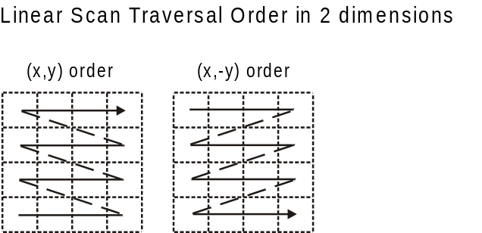

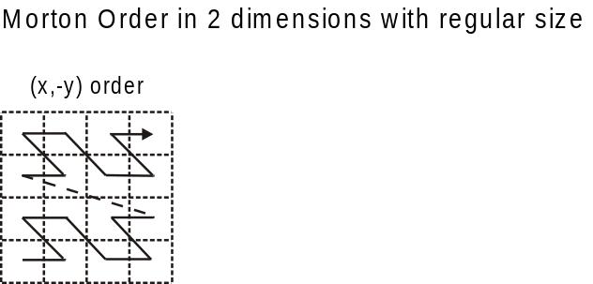

Figure 8-6 – Linear Scan Row Column (X,Y) Traversal Order and Morton (X,Y) Order
These two types of grids and traversal orders have applications for hydrographic data (e.g. section 8-6.2.5 – Morton Order).
Other traversal orders are defined in the ISO standard 19123.

Rectangular grids and irregularly shaped grids
The most common type of grid is a rectangular grid. Most images are defined on such a grid. A rectangular grid is a subtype of quadrilateral grid as defined in ISO 19123. A quadrilateral grid is a grid in which the curves are straight lines, and there is one set of grid lines for each dimension of the grid space. In this case the grid cells are parallelograms or parallelepipeds. A parallelepiped is a three-dimensional figure like a cube, except that its faces are not squares but parallelograms.

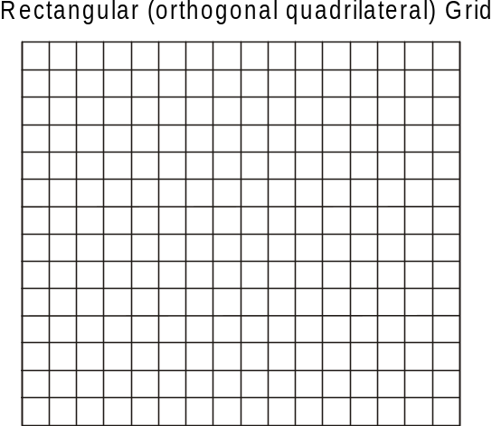
Figure 8-7 – Rectangular Grid
A grid may also have a non-rectangular or quadrilateral boundary. Such grids sometimes occur when scanning paper charts that include “insets” or “outsets” that change the boundary of the grid, however the grid can have any shape, as long as it can be traversed in a sequence that gives order to the cells. Figure 8-7 shows a Rectangular Grid. Figure 8-8 shows a quadrilateral grid with an outset, as might occur in a scanning operation.

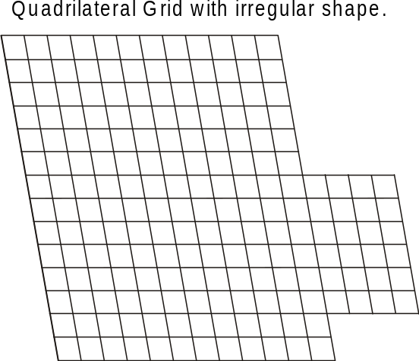
Figure 8-8 – Quadrilateral Grid with Outset

Very irregular shaped grids may be defined but require a more complex traversal rule than simple linear scanning.

Simple and tiled grids
A tiled grid is a combination of two or more grid tessellations for one set of data. The tiling scheme is essentially a second grid that is superimposed on the first simple grid. Each cell of the tiling scheme grid is itself a grid. A tiling scheme grid may also be used with vector data where each cell defines the boundaries of a particular vector data set. Tiling schemes are of particular value when data is sparse. For example, a raster image map of the United States might be tiled so that it is not necessary to include data over Canada or over the ocean to include Alaska and Hawaii. Figure 8-9 illustrates a tiled grid.

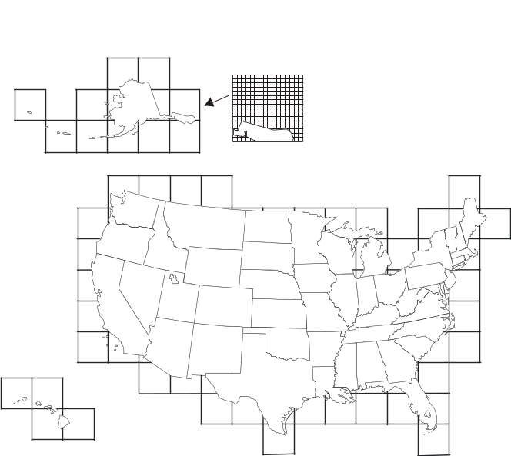
Figure 8-9 – Tiled Grid

Regular and variable cell sizes
Traditional grids are fixed ‘resolution’, most commonly composed of perpendicularly crossing lines of equal spacing on each dimension, creating square or rectangular cells. Gridding is a standard way of generalizing point data sets, by imposing a resolution or grid spacing, and calculating individual grid cell values based on a single attribute of the group of points contained within each cell. As well, image data is primarily gridded, based on the resolution of the sensor or uniform arbitrary pixel spacing.

Grids may also be established where the cell size varies within the grid. A common example is the “quad tree” that is commonly used in some Geographic Information Systems. Having a variable size grid cell allows variable resolution throughout the gridded surface, which is exhibited by the unequal spacing of parallel lines that form the grid, localized to given grid cells. This requires the normalization of data on each dimension, and the binary subdivision of each dimension in order to localize any given cell. When applied to point or image data, areas of high variability can be represented by small grid cells. Areas of low variability can be represented by large grid cells. Of course if the cell size varies in a grid, it must do so in a regular way so that the grid tessellation still covers the bounded area, and the traversal method must be able to sequence the cells in an order. In addition it is necessary to include information that describes the size of each cell with the cell.
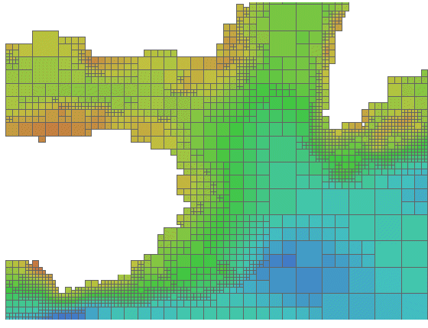
Figure 8-10 – Riemann Hyperspatial Grid Coverage
(showing depth from hydrographic sonar)

Data in a grid of variable cell size where adjacent like cells have been aggregated into larger cells, maintains the integrity of the original uniformly spaced data, while minimizing storage size. A grid with variable cell size supports null values, so incomplete data – that containing holes – can exist without the need to assign arbitrary values to regions of no data. This allows for a considerable amount of compaction over traditional grids because nothing is stored for cells with no data – they do not exist.

Figure 8-10 illustrates some variable size cells. If four adjacent cells (in two dimensions) have the same attribute value in the grid value matrix, then they may aggregated into one larger cell. In two dimensions this is known as a "QuadTree". This is of particular use in applications where resolution varies, or where data values tend to cluster.

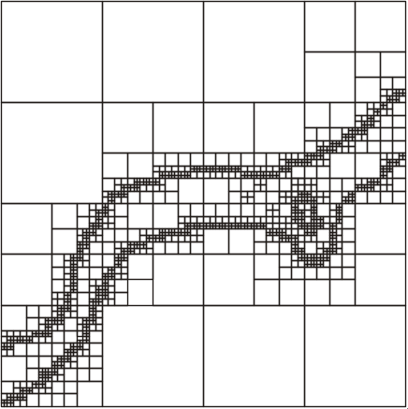
Figure 8-11 – Variable Cell Sizes

Variable size cells, as illustrated in Figure 8-11, are particularly useful for hydrographic data. Instead of representing bottom cover as soundings (point sets) it can be represented as a set of variable size cells. Each cell can carry several attribute values. Adjacent cells aggregate so the data volume is greatly diminished. Small cells exist where there is a rapid change in attribute value from cell to cell. Shoals, shore line and obstructions result in a number of small cells, where large relatively constant, or flat areas, such as the bottom of a channel result in a number of aggregated cells.

The Morton traversal order can handle variable size cells. The traversal progresses as shown in Figure 8-12. Morton order proceeds from left to right bottom to top cell by cell regardless of cell size. It increments in the X coordinate then the Y. This also extends to multiple dimensions where the increment is in X, then Y then Z then each additional dimension. Figure 8-13 shows Morton ordering in irregular grids and variable size grids. In this example Y, X ordering is used.
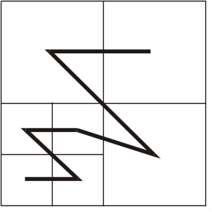
Figure 8-12 – Morton Order (X,Y)

Any space filling curve gives order to a bounded space, but the order imparted by the Morton order preserves nearness. This is a very important property. It means that two points that are close together in the grid are also close together in traversal order of the grid. This property derives from Riemann’s extension of the Pythagorean theorem into multiple dimensions into what is known as Riemann hyperspace.

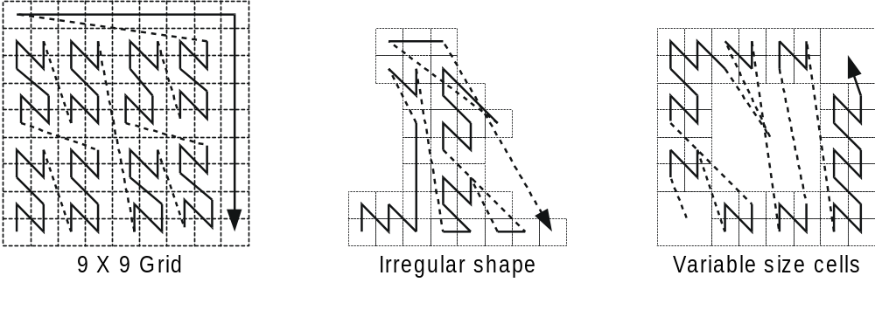
Figure 8-13 – Morton Order in irregular and variable size grids

Grids in 2 or 3 dimensions
Grids may exist in 2 or 3 dimensions. Not all traversal orders will work on higher dimensional grids, but both the linear scan traversal and Morton order traversal can be extended to 3 dimensions. Each dimension in an n-dimensional grid is orthogonal to all other dimensions. Thus, in a 3-dimensional grid or equal cell spacing, there are a set of perpendicularly crossing lines of equal spacing in each dimension, creating cubic cells. These can be thought of as volume elements – voxels.

A quadrilateral grid can easily be extended to 3 dimensions by repeating the grid for each cell “layer” in the third dimension. This is commonly done to support multiple bands of data for the same cell structure, however for true 3 dimensions where the number of cells in the third dimension is large the data volume can become enormous. Figure 8-14 shows a rectangular grid that is extended into the third dimension by repeating the grid for four different bands of data. Figure 8-15 shows a rectangular grid extended to cover a volume.

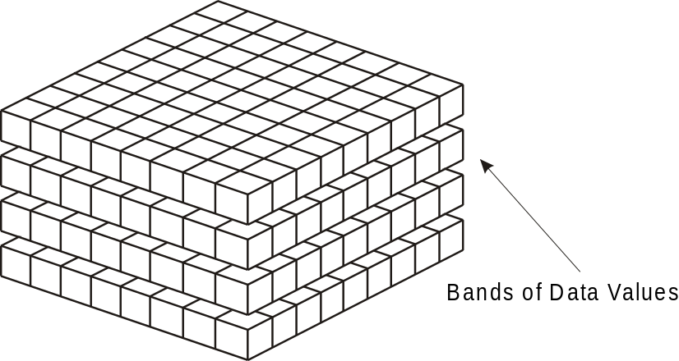
Figure 8-14 – Banding to Extend Attribute Space in a Rectangular Grid
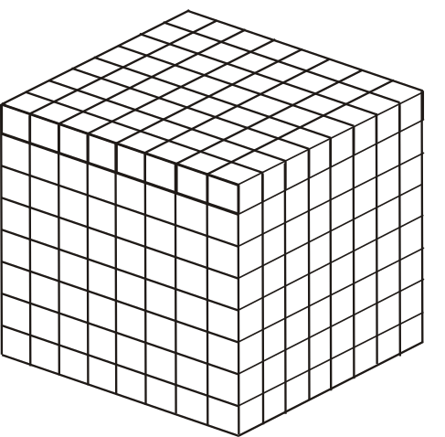
Figure 8-15 – A Rectangular Grid Extended to cover Three Dimensional Volume

Multidimensional Complex Grids exist in n-dimensions and will follow the rules of both these structures, allowing the creation for multidimensional, multi-resolution, aggregate structures. In hydrographic applications one is usually not interested in three dimensional solids but rather the three dimensional representation of the sea bottom and material, including floating material within the water volume related to the sea bottom. Such data sets are sparse, where most of the volume cells (voxels) are empty. If one allows three dimensional cells to aggregate into larger cells when they are the same (within a pre defined tolerance), then most of the empty cells disappear into a few larger aggregations. The use of variable size cells is useful in handling three and higher dimension data. A variable size cell grid in three dimensions is illustrated in Figure 8-16.
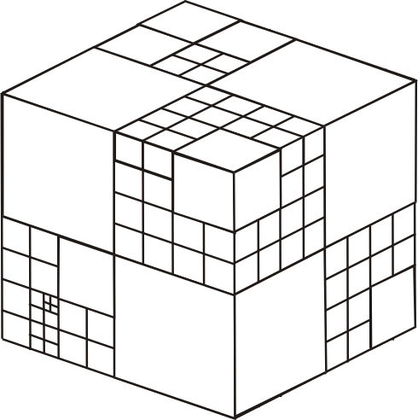
Figure 8-16 – A Variable Size Cell Grid in Three Dimensions

TIN
The Triangular Irregular Network is a method of describing variable density coverage data based on a set of triangles. The TIN structure is very flexible for analysis. Since each triangle is a locally flat surface it is straight forward to calculate the intersection of an arbitrary curve with a surface represented as a TIN. Attributes can be applied to each triangular face, and it is easy, but computationally intensive, to process the faces geometrically, in order to calculate contour lines. In a dynamic navigation system one could easily calculate the potential intersection of a ship's hull with the bottom surface represented as a TIN, and therefore easily determine a dynamic safe contour. The calculation of the intersection of a vector with the surface of a TIN triangle is the simple calculation of the intersection of a line and a plane. An example TIN showing variable size TIN triangles and the TIN vertex points is shown in Figure 8- 17.
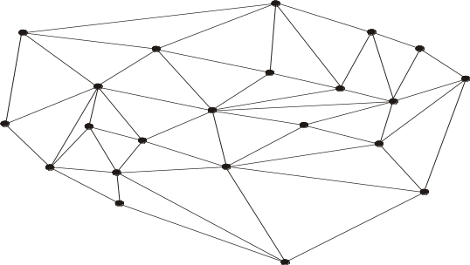
Figure 8-17 – An example coverage composed of TIN triangles
A TIN is composed of a set of triangles. The vertices at the corners of each triangle are shared with the adjacent triangle. These vertices form the control points of the coverage function. There is an inherent overhead involved in a TIN since one must store both the triangles and the vertices. Attribute values are attached to the triangles, whereas the geometry is derived from the position of the vertices. A TIN may be described either by having the triangles reference the shared vertices at their corners, or by having the vertices indicate which triangles they are attached to. Having the triangles reference the vertices is the simpler structure since each triangle has exactly 3 vertices, whereas a vertex may be shared between a variable number of triangles.

A TIN is useful in representing variable density data, since the triangles may be larger where the data is locally smooth, and more dense to represent data with more rapidly changing values. If the points of the TIN are carefully chosen to represent ridges, valleys and other significant features, then the TIN can result in a significant data compaction; however, if a TIN is automatically generated from an arbitrary set of data points the data volume can increase over the original source data, or significant information can be lost, Since a TIN coverage can be of any shape it can be fitted to cover an area of interest.

Data Set Structure
Coverage data as used in S-100 is relatively simple data. It consists of a set of data values together with metadata that describes the meaning of these values. The data values are organized according to a spatial schema. For most types of coverage data this schema takes the form of a coverage schema. The exception is for Point Set data, which is a set of points.
A data set consists of an S100_IG_Collection composed of coverages or point sets. Metadata is associated at several levels. Metadata maybe associated with the data set as a whole, or with the coverage or point set. Metadata may also be associated with particular data elements where needed. More detailed metadata at a lower level overrides general metadata for an entire coverage or collection. Metadata may also be associated with particular regions of a data set or other grouping of data set elements.

The description of metadata may be organized in several different ways. In this standard the metadata is organized into modules. The Discovery Metadata Module relates to the data set as a whole whereas other metadata applies to the S100_IG_Collection. The S100_Collection Metadata Module refers to the S100_Discovery Metadata Module, the S100_Structure Metadata Module, the S100_Acquisition Metadata Module and the S100_Quality Metadata module as sub-components.

Coverages or Point Set data may also be organized into tiles. Metadata may also be associated with a tile. The overall structure of a data set is illustrated in Figure 8-18.
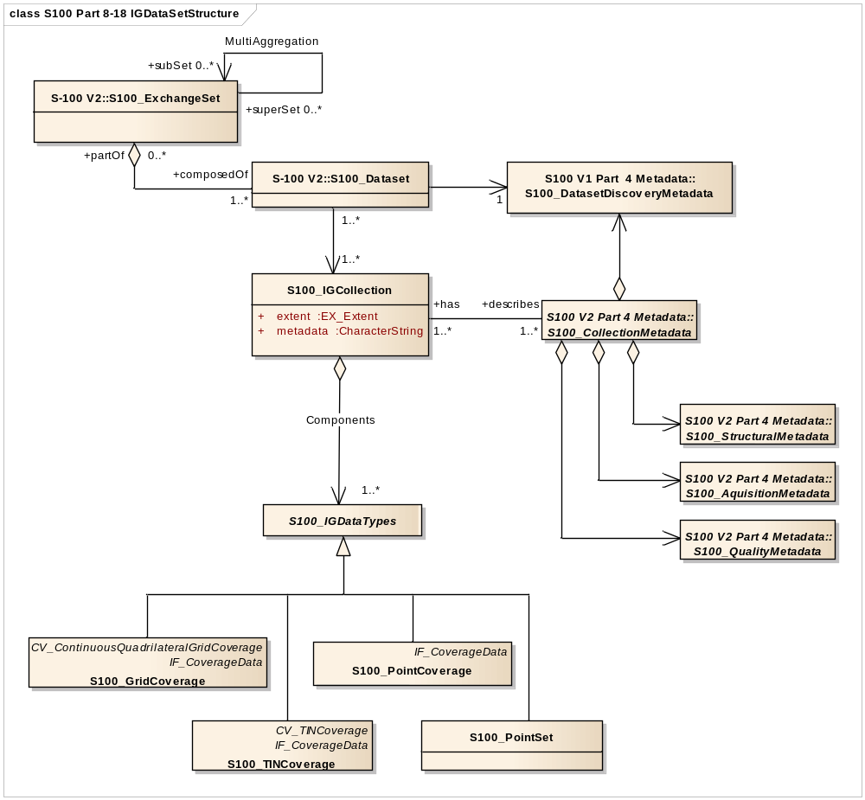
Figure 8-18 – Data Set Structure

Data Set Class
A data set is an identifiable collection of data that can be represented in an exchange format or stored on a storage media. A data set can represent all or a part of a logical data collection and may include one or many tiles of data. The content of a data set is defined by the Product Specification for that particular type of data and is normally suited to the use of that data. A product specification for a particular data type needs to have a plan that indicates the organization of that data product. For example, a simple gridded bathymetry model based product may have only one bathymetry grid coverage, and a tiling scheme that indicates that every data set contains one tile. More complex products may include several colocated coverages and more complex tiling schemes such as a quad tree based variable size tiling scheme, where one data set may, at times contain more than one tile. The data set is the logical entity that can be identified by the associated discovery metadata, not the physical entity of exchange.

S100_Discovery Metadata Module
Associated with a data set is a set of discovery metadata that describes the data set so that it can be accessed. It consists of the "core" metadata defined in ISO 19115.

S100_Transmittal
A transmittal is the encoded exchange format used to carry all, part of, or several data sets. It represents the physical entity of exchange. The transmittal is dependent upon the encoding format and the exchange media. A transmittal on a physical media such as a DVD may carry a number of data sets, whereas a transmittal over a low bandwidth telecommunications line may carry only a small part of a data set. Any metadata carried with a transmittal is integral to the transmittal and may be changed by the exchange mechanism to other exchange metadata as required for the routing and delivery of the transmittal. A common exchange mechanism would be to carry a whole data set on one physical media such as a CD-ROM. Transmittal metadata is not shown because any transmittal metadata, exclusive of the information in the Discovery Metadata Module, is dependent upon the mechanism used for exchange, and may differ from one exchange media or encoding format to another. An example of transmittal Metadata would be counts of the number of data bytes in a unit of exchange.

S100_IG_Collection
An S100_IG_Collection represents a collection of data. A collection may include multiple different data types over a particular area, or multiple coverages of data of the same coverage type, but representing different surfaces. For example a collection may consist of a grid coverage and a point set over the same area, where the grid coverage represents a bathymetry surface and the point set a number of sounding points.

S100_Collection Metadata Module
Associated with an S100_IG_Collection is a set of collection metadata that describes the data product as represented in the collection. It consists of a number of sub-components that include the Discovery Metadata Module as well as the Structure Metadata Module, the Acquisition Metadata Module and the Quality Metadata Module. Metadata from the Discovery Metadata Module may be applied to a collection so that the entire collection may be discovered. The other metadata modules are descriptive metadata defined in ISO 19115.

S100_Structure Metadata Module
Associated with a data type is a set of structure metadata that describes structure of the coverage or point set.

S100_Acquisition Metadata Module
Associated with a data type is optionally one or many sets of acquisition metadata that describes source of the data.

S100_Quality Metadata Module
Associated with a data type is optionally one or many sets of quality metadata that describes quality of the data.

S100_IG_Data Type
This is an abstract class used to represent all of the types of coverage or point set data that may occur in an S100_IG_Collection.

Components
This role name components identifies the set of data types contained in a collection.

S100_Tiling Scheme
This class is used to describe the tiling scheme used with the S100_Collection. Metadata identifying a particular instance of a tile is included in the structure module.

Tiling Scheme
Tiling is one method of reducing the volume of data in a data set to manageable proportions. Clause 7.2.2.2 illustrates the use of tiling. In a data set there must be information both describing the tiling scheme and also about the instance of a tile or tiles carried in that particular data set. The class S100_TilingScheme carries information about the tiling scheme as a whole. There may only be one tiling scheme defined for a particular data collection. Within a data warehouse (database) there may be several overlapping tiling schemes defined where any of the tiling schemes may be used as the basis of data extraction from the data warehouse.

A tiling scheme is itself a discrete coverage. It is normally a simple rectangular grid with tiles of equal density. Such a grid coverage may also be defined with tiles of variable density. A more complex tiling scheme may also be defined as a discrete polygon coverage. An example is a data collection consisting of elevation cut along political boundaries. These types of tiling schemes are illustrated in Figure 8-19. Other tiling schemes are also possible. In fact, any type of discrete coverage may be used to establish a tiling scheme.

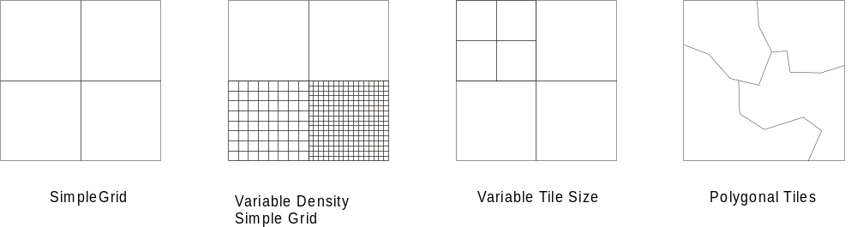

Figure 8-19 - Tiling Scheme Types
Any tiling scheme used must be completely described as part of the product specification for a particular data product. This includes the dimensions, location and data density of tiles as well as a tile identification mechanism (tileID).

Spatial Schema
Each of the S100_IGDataTypes has a specific spatial schema that describes the structure of that data type. The four data types identified in the S100 Image Gridded and Coverage component are the:
- S100_Point Set;
- S100_Point Coverage:
- S100_TIN_Coverage; and
- S100_Grid Coverage.

S100_Point Set Spatial Model
An S100_Point is a single point referenced to a 3-D coordinate reference system. Its value is carried as a coordinate rather than an attribute. Such points are generated by certain types of sensors. An S100_Point Set is not a coverage. Each Point in a Point Set has only one value. A Point Set can be used to generate a Point Coverage. The class S100_PointSet is illustrated in Figure 8-20.

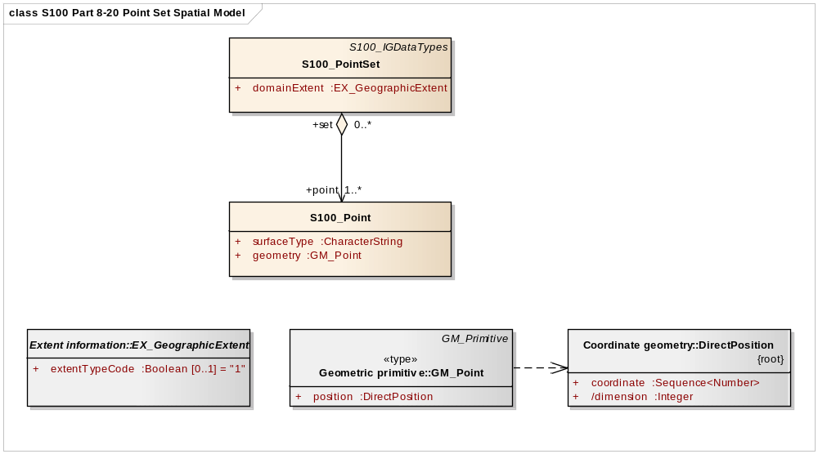
Figure 8-20 - S100_Point
The attribute domainExtent describes the spatial extent of the domain of the Point Set.
The attribute metadata provides a link to metadata that describes the Point Set. Logically the link is any URI, but it may be implemented as a CharacterString data type that identifies the associated files of metadata.
The attribute surfaceType identifies the type of surface that is described by the point, for example, sounding as measured by sonar.
The attribute geometry contains an instance of GM_Point.

S100_PointCoverage Spatial Model
An S100_Point Coverage is a type of CV_DiscretePointCoverage from ISO 19123. The attribute values in the value record for each CV_GeometryValuePair represent values of the coverage, such as bathymetric soundings.

The class S100_Point Coverage (Figure 8-21) represents a set of values, such as bathymetric depth values, assigned to a set of arbitrary X,Y points. Each point is identified by a horizontal coordinate geometry pair (X,Y) and assigned one or more values as attribute values. These values are organized in a record for each point.

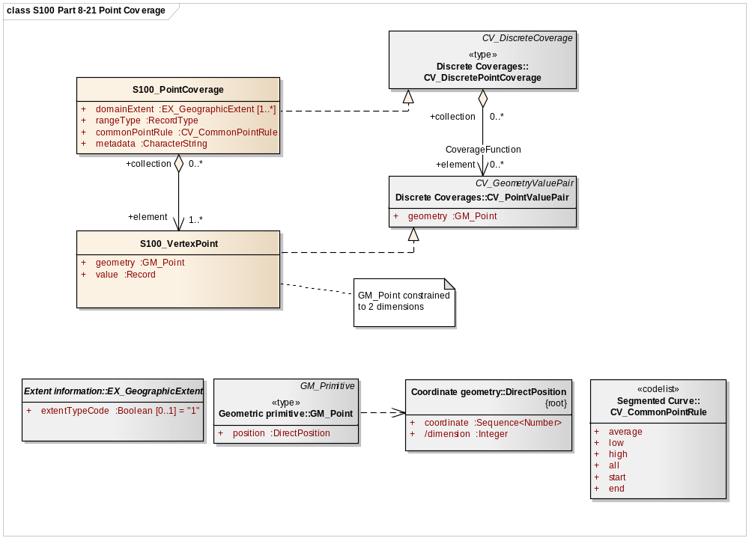
Figure 8-21 - S100_PointCoverage
The attribute domainExtent describes the spatial extent of the domain of the coverage.
The attribute rangeType describes the range of the coverage. It uses the data type RecordType specified in ISO/TS 19103. An instance of RecordType is a list of name:data type pairs each of which describes an attribute type included in the range of the coverage.
The attribute metadata provides a link to metadata that describes the coverage. Logically the link is any URI, but it may be implemented as a CharacterString data type that identifies the associated files of metadata.

The attribute commonPointRule describes the procedure used for evaluating the coverage at a position that falls on the boundary or in an area of overlap between geometric objects in the domain of the coverage. It takes a value from the codelist CV_CommonPointRule specified in ISO 19123. The rule shall be applied to the set of values that results from evaluating the coverage with respect to each of the geometric objects that share a boundary. Appropriate values of the CV_CommonPointRule include 'average', 'high', and 'low'. For example, data used for bathymetric purposes may make use of the 'high' value to ensure that obstructions such as rocks or shoals are emphasised.

The attribute geometry contains an instance of GM_Point.

The attribute value contains a record which conforms to the RecordType specified by the rangeType attribute.

S100_TIN Coverage Spatial Model
A TIN coverage is a type of CV_ContinousQuadrilateralGridCoverage as described in ISO 19123. The attribute values in the value record for each CV_GeometryValuePair represent values for each of the vertex corners of the triangle. Any additional attributes related to a TIN triangle may be described as attributes of CV_ValueTriangle.

A TIN covers an area with a unique set of non-overlapping triangles where each triangle is formed by three points. The geometry for a TIN is described in ISO 19107 and a TIN coverage is described in ISO 19123. TIN coverages are particularly useful for representing elevation or bathymetry in some applications. It is easier to calculate an intersection with a coverage surface when it is represented as a TIN. The class S100_TINCoverage is illustrated in Figure 8-22.

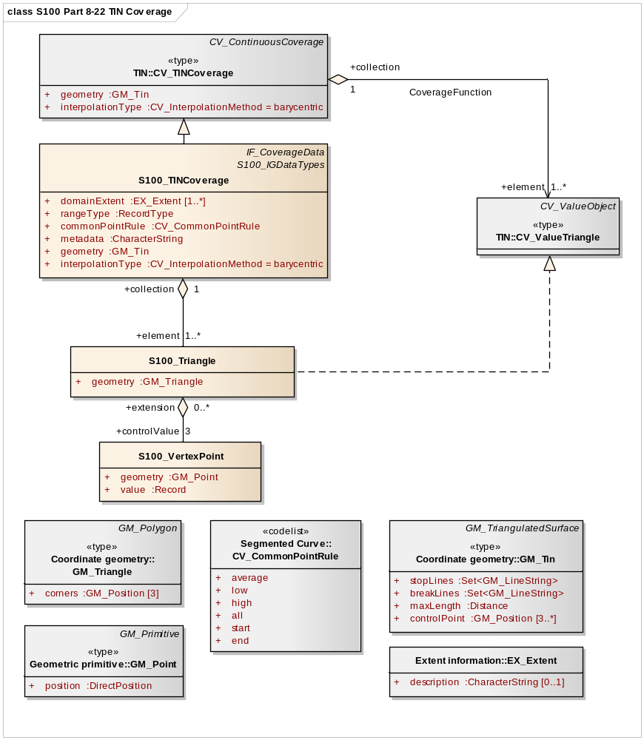
Figure 8-22 - S100_TIN Coverage
The attribute geometry describes the network of triangles that form the basis of the TIN. The triangles lie on a 2 dimensional manifold with the X,Y coordinates of the points at the vertices of the triangles representing the position on the manifold and the attribute.

The attribute interpolationType specifies the interpolation method recommended for the evaluation of the S100_TINCoverage where the value is taken from the codelist CV_InterpolationMethod with the value "barycentric". The barycentric position S within a value triangle composed of the CV_PointValuePairs (P1, V1), (P2, V2), and (P3, V3), is (i, j, k), where S = iP1 + jP2 + kP3 and the interpolated attribute value at S is V = iV1 + jV2 +kV3
The attribute domainExtent describes the spatial extent of the domain of the coverage.

The attribute rangeType describes the range of the coverage. It uses the data type RecordType specified in ISO/TS 19103. An instance of RecordType is a list of name:data type pairs each of which describes an attribute type included in the range of the coverage.

The attribute metadata provides a link to metadata that describes the coverage. Logically the link is any URI, but it may be implemented as a CharacterString data type that identifies the associated files of metadata.

The attribute commonPointRule describes the procedure used for evaluating the coverage at a position that falls on the boundary or in an area of overlap between geometric objects in the domain of the coverage. It takes a value from the codelist CV_CommonPointRule specified in ISO 19123. The rule shall be applied to the set of values that results from evaluating the coverage with respect to each of the geometric objects that share a boundary. Appropriate values of the CV_CommonPointRule include 'average', 'high', and 'low'. For example, data used for bathymetric purposes may make use of the 'high' value to ensure that obstructions such as rocks or shoals are emphasised. The use of the commonPointRule occurs where a set of geometric objects are involved, such as the triangles in a TIN

The attribute geometry contains an instance of GM_Tin. For each S100_Triangle the attribute geometry contains GM_Triangle.

Three vertex points define a triangle. The attribute geometry for a S100_VertexPoint is an instance of GM_Point. The attribute value contains a record restricted to one entry that defines the coverage value at the vertex (e.g. depth for a bathymetric TIN vertex point).

S100_Grid Coverage Spatial Model
The class S100_Grid Coverage (Figure 8-23) represents a set of values assigned to the points in a 2D grid. Several organizations of grids are available from ISO 19123 with different grid traversal orders, and variable or fixed grid cell sizes. S-100 makes use of two types of grid organizations, the simple quadrilateral grid with equal cell sizes traversed by a linear sequence rule, and the variable cell size quadrilateral grid traversed by a Morton Order sequence rule. This variable cell size grid organization is known as the Quad Tree for a two dimensional grid.

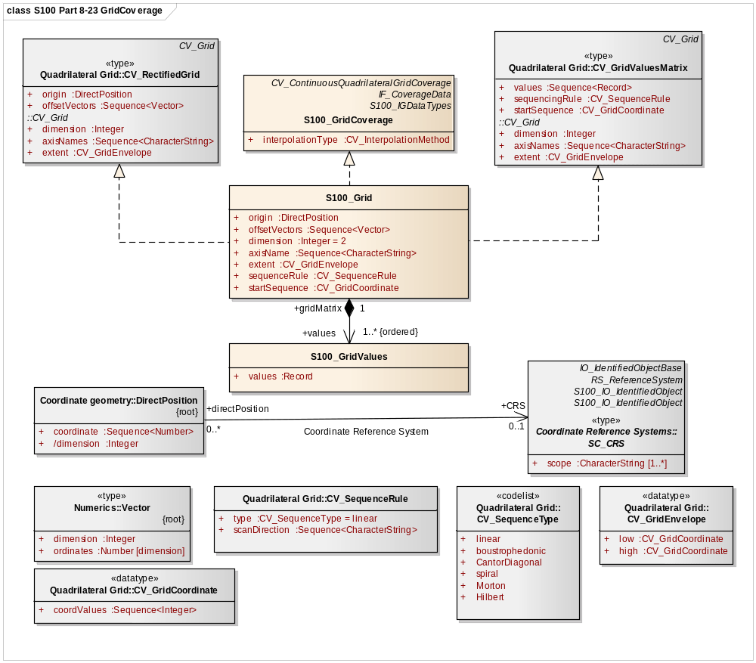
Figure 8-23 - S100_Grid Coverage

The attribute interpolationType describes the interpolation method recommended for evaluation of the S100_GridCoverage. The interpolation methods available are: Bilinear interpolation, Bicubic interpolation, Nearest-neighbour, and Biquadratic interpolation. These methods are defined in ISO 19123.

The class S100_Grid is a realization of CV_RectifiedGrid and CV_GridValuesMatrix from ISO 19123. The attributes inherit from the classes in ISO 19123. The attribute dimension specifies the dimension of the S100 grid. The attribute axisNames specifies the names of the grid axes. The attribute origin specifies the coordinates of the grid origin with respect to an external coordinate system.
The data type DirectPosition, specified in ISO 19107, has an association through the role name coordinateReferenceSyetem to the class SC_CRS specified in ISO 19111 which specifies the external coordinate reference system.

The attribute offsetVectors specifies the spacing between grid points and the orientation of the grid axis with respect to the external coordinate reference system identified through the attribute origin. It uses the data type Vector specified in ISO/TS 19103.

For simple grids with equal cell sizes the offset vector establishes the cell size. For variable cell size grids (Quad Tree grids) the offset vector establishes the minimum cell size. The actual cell size is included as an attribute in the data record that describes the level of aggregation of the quad structure.

The attribute extent specifies the area of the grid for which data are provided. It uses the type CV_GridEnvelope specified in 19123 to provide both the CV_GridCoordinates of the corner of the area having the lowest grid coordinate values and the CV_GridCopordinates of the corner of the area having the highest grid coordinate values. CV_GridCoordinate is specified in 19123.

The attribute extent effectively defines a bounding rectangle describing where data is provided. For simple grids with equal cell sizes, if data is not available for the whole area within this rectangle, then padding with null values shall be used to represent areas where no data is available. For variable cell size grids (Quad Tree grids) a characteristic of the Morton Order traversal is that nonrectangular areas may be represented. In this case the attribute extent is a bounding rectangle that encloses the area of the grid for which data are provided.
The attribute sequencingRule specifies the method to be used to assign values from the sequence of values to the grid coordinates. It uses the data type CV_SequenceRule specified in ISO 19123. Only the values "linear" (for a simple regular cell size grid) and "Morton" (for a Quad Tree Grid) shall be used for data that conforms to this standard.

The sequence rule for a regular cell size grid is simple. When the cells are all of the same size, the cell index can be derived from the position of the Record within the sequence of Records. For a variable cell size grid the sequence order is more complex. The cell index either needs to be carried with each of the associated record values or it can be calculated based on each cell size.

The attribute startSequence identifies a value of CV_GridCoordinate to specify the grid coordinates of the grid point to which the first in the sequence of values is to be assigned. The choice of a valid point for the start sequence is determined by the sequencing rule.

The class values shall be a sequence of Records each containing one or more values to be assigned to a single grid point. The Record shall conform to the RecordType specified by the rangeType attribute of the GridCoverage with which the Grid is associated. For simple grids with equal cell sizes the attribute values may be only data values, but for the variable cell size Quad Tree grid the record type shall include an index number and the cell size (aggregation level) for the cell.

For simple grids with equal cell sizes the sequenceRule attribute of an S100_Grid equals "linear" and the offset vector establishes the cell size. The attribute extent specifies the area of the grid for which data is provided. For variable cell size grids (Quad Tree grids) the sequenceRule attribute equals Morton and the offset vector establishes the minimum cell size. The actual cell size is included as an attribute in the data record that describes the level of aggregation of the quad structure. The attribute extent specifies a bounding rectangle within which data is provided. Which cells are included in the data set is determined from the Morton ordered sequence of cells.

Rectified or Georeferencable Grids
The model given below in Figure 8-24, shows that a Grid can be of two types Rectified or Georeferencable and that the Grid Value matrix is a subtype of the general grid object. The Grid Value Matrix may have several different sequence rules. These are given in a codelist of sequence type. Only linear and Morton order are used in this document.

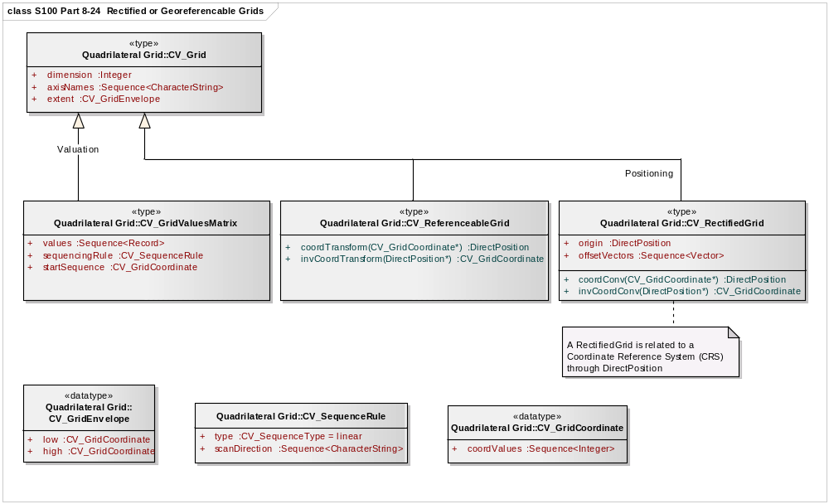
Figure 8-24 - Rectified or Georeferencable Grids

The attribute dimension specifies the dimension of the S100_Grid.
The attribute axisNames specifies the names of the grid axes.
The attribute extent specifies the area of the grid for which data are provided. It uses the type CV_GridEnvelope specified in 19123 to provide both the CV_GridCoordinates of the corner of the area having the lowest grid coordinate values and the CV_GridCopordinates of the corner of the area having the highest grid coordinate values. CV_GridCoordinate is specified in 19123.
The attribute extent effectively defines a bounding rectangle describing where data is provided.
The attribute Values of the CV_GridValuesMatrix class defines a sequence of records. These are described using the S100_GridValues class.
The attribute sequencingRule specifies the method to be used to assign values from the sequence of values to the grid coordinates.
The attribute startSequence identifies a value of CV_GridCoordinate to specify the grid coordinates of the grid point to which the first in the sequence of values is to be assigned.
A Rectified Grid is related to the Coordinate Reference System through the attribute Direct Position.
A Referencable Grid may be related to a Coordinate Reference System through a Transform operation.

Data Spatial Referencing
Spatial referencing for gridded data and for point set data and TIN data are handled differently. Point set data includes a coordinate direct position for each point in the point set. TIN data includes a point at each vertex of a TIN triangle. Spatial referencing of direct positions is described in ISO 19111 Spatial referencing by coordinates, and is the same for point set, and TIN data as it is for other types of vector data. Gridded data references the grid as a whole.

Gridded Data Spatial Referencing
The two spatial properties of gridded data describe how the spatial extent was tessellated into small units and spatial referencing to the earth. The ISO 19123 standard indicates that a grid may be defined in terms of a coordinate reference system. This requires additional information about the location of the grid’s origin within the coordinate reference system, the orientation of the grid axes, and a measure of the spacing between the grid lines. A grid defined in this way is called a rectified grid. If the coordinate reference system is related to the Earth by a datum, the grid is a georectified grid. The essential point is that the transformation of grid coordinates to coordinates of the external coordinate reference system is an affine transformation. The class SC_CRS is specified in ISO 19111. A referenceable grid is one that can be converted to a rectified grid by a coordinate transform.

Georectified
Georectified gridded data is uniformly spaced gridded data. Any cell in a georectified gridded data can be uniquely geolocated, given the cell spacing, grid origin and orientation. In most georectified gridded data, cell size is constant across the whole coverage and also equates to the cell spacing. (Note, however, that uniformly spaced gridded data may be uniformly spaced in terms of image coordinates, and not geolocatable.) For georectified gridded data, information as simple as the map coordinate values of any two cells not in the same row and column can geolocate all cells in the coverage to the map coordinate system, since cell spacing, grid origin and orientation can be derived from the coordinates of the two cells.

It should be pointed out that the cell spacing (i.e., cell size) in the above definition is the distance measured at the map projection coordinate system. Uniform spacing in a map coordinate system may not necessarily indicate equal spacing on the earth’s surface, depending on the map projection selected. For example, a cell size of 0.1 degree longitude in the geographic coordinate system (i.e. lat/long) corresponds to different surface distances in kilometres at high and low latitudes.

The term “uniform spacing” means that there is equal spacing in some defined coordinate system. “Regular spacing” means that there is some function that equates location to cell spacing.

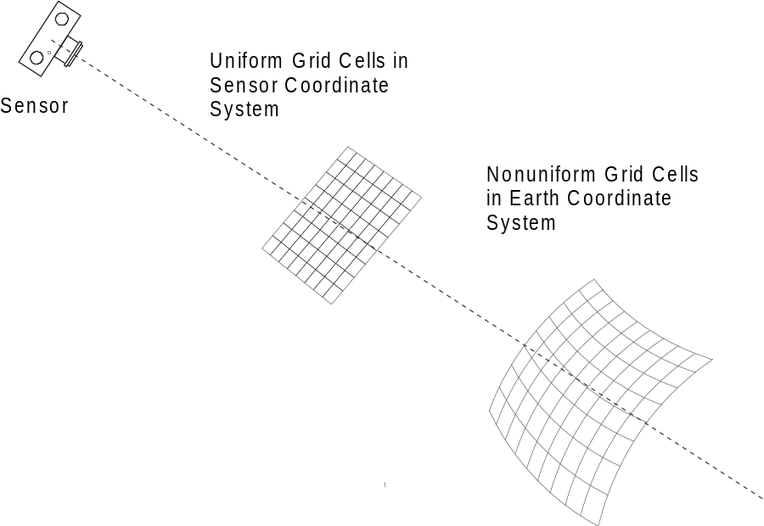
Figure 8-25 - Non Uniform Spacing of Grid Cells

Ungeorectified
Ungeorectified gridded data is geospatial gridded data whose cells are non-uniformly spaced in any geographic/map projection coordinate system. Therefore, the location of one cell in an ungeorectified gridded data cannot be determined based on another cell’s location.

Ungeorectified gridded data can be further classified into georeferenced and georeferencable subclasses, depending on whether information is provided with a data set that allows determination of the geolocation of a cell.

Georeferenced
Georeferenced gridded data is gridded data whose cell locations can be uniquely determined through certain geolocating algorithms, such as warping, using information provided with the data. Most raw remote sensing data and raw hydrographic sonar data are in the georeferencable form.

Sensor
Georeferenced Grid Data
Transform
Georeferencable grid data
Figure 8-26 - Georectified Data

Georeferencable
Georeferencable gridded data is ungeorectified gridded data that does not include any information that can be used to determine a cell’s geographic coordinate values, for example, a digital perspective aerial photograph without georectifiction information included. (An aerial photograph can be georeferenced through a set of ground control points.)

The difference between georectified and georeferenced data is that cell spacing is constant in a georectified data while it may be variable in georeferenced data. In georectified data, the location of any cell can be determined given the data’s cell spacing, grid orientation and the coordinates of any one cell. In georeferenced data, there is no predefined association between one cell’s location and that of another; each cell’s location might be independently calculated. Georectified gridded data are normally obtained from georeferenced data through georectification (also called geometric correction). The georectification process involves two steps. The first step is to calculate the grid coordinates (e.g. row and column) of regularly spaced cells located at the map coordinate x, y. This step is called coordinate mapping. The second step is to assign the cell with an attribute value based on the attribute values at the corresponding and neighbouring grid coordinates. This step is called resampling. Spatial referencing information for imagery data is carried as metadata.

Point Set Data and TIN Triangle Vertex Spatial Referencing
Point sets and TIN triangles are described in the ISO Spatial Schema standard 19107, which has been profiled as part of S-100. Each point in a point set is located by a direct position. The spatial referencing system that relates to the direct positions in the set is referenced by the spatial schema, through the same SC_CRS object.

Imagery and Gridded Data Metadata
The general structure for imagery and gridded data given in Figure 8-3 shows that metadata is one of the primary components of an imagery and gridded data set. A gridded data set consists of attribute data contained in a grid value matrix and associated metadata. Everything except for the actual grid cell attributes is metadata. Some of the metadata is structural, such as the metadata required to define the geometric structure or spatial referencing, while other metadata describes the meaning of the data set. Some of the structural metadata will be carried as attributes of the Grid Value Matrix Object. Figure 8-27 is a model showing the relationship to metadata for all coverage data. This figure is a generalization of ISO 19102-2.

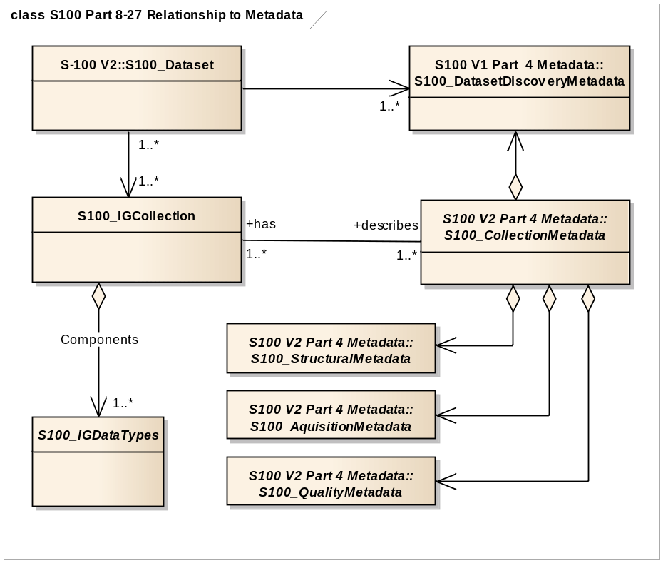
Figure 8-27 – Relationship to Metadata

The metadata for all types of geographic data is covered in the metadata standard ISO 19115 Metadata. This standard includes mandatory identification metadata that describes the data set. This is called Catalog or Discovery metadata. It also includes some metadata describing the content of a data set. This is particularly true at the feature level. Much of the metadata corresponding to vector based geometric data does not apply to imagery and gridded data. The metadata elements in 19115 are used where possible to address the requirements for Imagery, Gridded and Coverage data. Some basic imagery metadata elements are already defined in 19115. Other metadata elements primarily related to acquisition and processing are addressed in ISO 19115-2 Geographic information - Metadata - Part 2: Extensions for imagery and gridded data. The minimum amount of metadata required to describe a coverage data is addressed in 19115. The details of sensor models and their associated data models and metadata are provided in ISO 19130 Geographic information - Sensor and data models for imagery and gridded data. Metadata for S-100 is given in Part 4. The specific metadata for S-100 Imagery and Gridded Data is shown in Appendix 8-D.
The ISO 19115:2003 metadata standard has been revised and is now ISO 19115-1:2014 Geographic information -- Metadata -- Part 1: Fundamentals. All of the metadata elements from the original ISO 19115:2003 still exist but may have been extended or moved. Additional metadata related standards have been developed in ISO as extensions to the ISO 19130:2010 standard including ISO 19130-2:2014 Geographic information -- Imagery sensor models for geopositioning -- Part 2: SAR, InSAR, lidar and sonar. In addition a series of Calibration and Validation standards ISO 19159-1:2014 Optical sensors, 19159-2 Lidar, 19159-3 Sar/InSar exist or are in development.

Quality
The general concept for handling quality in the ISO 19100 series of standards is defined in the ISO 19113 “Quality principles”. The procedures to evaluate quality are defined in the ISO 19114 “Quality evaluation procedures”. ISO 19138:2006 “Data quality measures” provides a definitive set of measures. The metadata quality elements from ISO 19115:2003 have been moved to a new standard ISO 19157:2013 Geographic information -- Data quality.

The ISO 19129 standardizes quality aspects that are specific for imagery, gridded, and coverage data. The testing of the quality according to this standard is model based. The quality measures are attributes or constraints of the classes of the model. Appendix 8-C shows the proposed top-level classes of the quality model.

Imagery and Gridded Data Portrayal
The mechanism for portrayal is out of scope for this component of S-100. It is described in the Portrayal component of S-100 Part 9. The basic mechanism for feature centric rule based portrayal is given in ISO 19117 “Portrayal”. However, certain information may need to be carried with a set of imagery and gridded data to support external portrayal mechanisms.

Imagery and Gridded Data Encoding
Details of encoding are out of scope of this document except for the identification of "picture/image" coding standards and associated data coding standards. That is, relation to ISO/IEC JTC1/SC24 (computer graphics and image processing) concerning the ISO 12087-5 Basic Imagery Interchange Standard BIIF and ISO 15948 Portable Network Graphics (PNG) and ISO/IEC JTC1/SC29 (Coded representation of picture, audio and multimedia/hypermedia information) concerning the ISO 15444 JPEG 2000 standards for "picture/image" and ISO 19118 (Geographic Information – Services). A reference to other existing standards for encoding image/gridded data such as CEOS, HDF-EOS, GeoTIFF, and other specifications is required to ensure backward compatibility.

Spatial Schema for Point Sets
The spatial schema for point sets for four types of imagery and gridded data are described in this section of S-100. An application schema for point sets is described in the S-100 spatial schema section Part 7 clause 7.5.2.19.

Gridded data
This application schema defines a quadrilateral grid coverage with associated metadata. The metadata is generically referenced to ISO 19115 and 19115-2. A specific choice of metadata has not been made in this schema. This schema can serve for both "matrix" and "raster" data [see Appendix 8-D] dependent upon the metadata chosen.

The gridded data consists of a single feature - the "image" or "matrix" together with associated metadata taken from MD_Metadata (or MI_Metadata). The CV_Coverage serves as the spatial attribute of the gridded data set. It defines an area that is "covered" by the coverage function. For the continuous coverage defined in this application schema, the coverage function returns a value for every point in the area covered based on an interpolation function. The Grid Value Matrix is a set of values which drives the interpolation function. It this case the value matrix is a grid traversed by a linear scan (x,y) traversal rule. The spatial referencing is defined by the coordinate reference system. This template application schema supports the majority of imagery and gridded data applications.

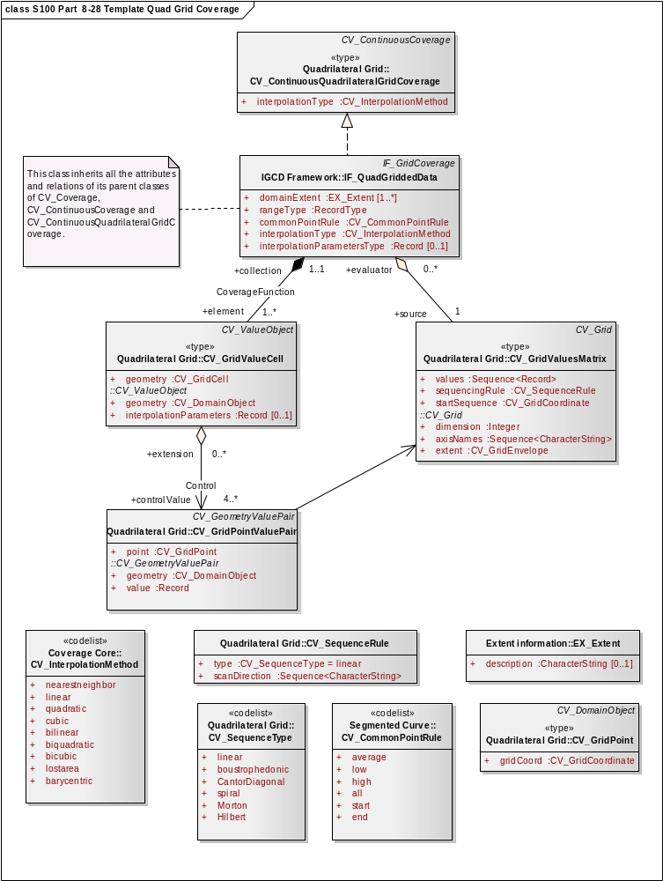
Figure 8-28 - Template Application Schema for a Quadrilateral Grid Coverage

Scanned Image
This application schema defines a grid coverage with associated metadata for the use of supporting a scanned paper chart in compliance with S-61. The model is the same as that shown in figure 8-28, except that the metadata is defined more precisely.

The following table assigns the metadata identified in S-61 to the metadata classes in ISO 19115.
Table 8-2 — S-61 Metadata in terms of ISO 19115
S-61 | ISO 19115 class
Producing Agency | MD_Metadata - contact -  CI_ResponsibleParty (including organization name, contact info and role of producing agency)
MD_Metadata - identificationInfo -
MD_Identification - purpose -
"Raster Nautical Chart"
 | MD_Constraints_useLimitation
 | MD_Constraints_MD_LegalConstraints
RNC number | MD_Identification - citation -  CI_Citation - identifier
Chart identifier | LI_Lineage - LI_Source - sourceCitation -  CI_Citation - identifier
RNC edition date | MD_Metadata - dateStamp -  Date
Chart edition date | LI_Lineage - LI_Source - sourceCitation -  CI_Citation - edition
Last update or Notice to Mariner applied | LI_Lineage - LI_Source - SourceStep - LI_ProcessStep_dateTime
 | MD_DataIdentification - topicCategory - TopicCatagoryCode - "2" (grid)
 | MD_DataIdentification - SpatialRepresentationType - SpatialRepresentationTypeCode - "oceans"
Chart scale | MD_ReferenceSystem
Orientation of North | MD_ReferenceSystem
Projection and projection parameters | MD_ReferenceSystem
Horizontal Datum | MD_ReferenceSystem
Horizontal Datum shift | MD_ReferenceSystem
Vertical datums | MD_ReferenceSystem
Depth and Height units | MD_ReferenceSystem - EX_VerticalExtent - unitOfMeasure
Pixel Resolution | MD_DataIdentification - spatialResolution - MD_Resolution -
Transform to allow geographic positions to be converted to RNC coordinates | MD_ReferenceSystem
Colour palettes for daytime, nighttime and dusk | MD_PortrayalCatalogueReference
information to handle notes, diagrams and marginalia | Notes and textual marginalia may be captured as MD_MetadataExtensionInformation, whereas diagrams must be handled by reference to an associated data file containing the diagram.
source diagram | Textual description of source may be captured as MD_MetadataExtensionInformation, whereas a source diagram must be handled by reference to an associated data file containing the diagram.
update metadata including:  - producer of update,  - update number,  - date,  - identifier of which RNC to which it applies,  - chart edition to which it applies,  - changes to metadata, and  - information so it can be applied automatically | MD_MaintenanceInformation together with MD_Identification

Variable Cell Size Grid
This application schema describes a grid of variable cell size using the capability for variable cell size grids described in ISO 19123. The traversal order is the Morton order in order to permit support of three (or more) dimensions. This is of particular use for hydrographic data where large volumes of sonar data results in extensive bottom cover in a 3D grid, but where the cells of similar depth can easily be aggregated.

The application schema given in Figure 8-27 applies with minor changes. The type of grid changes to a CV_ContinuousCoverage

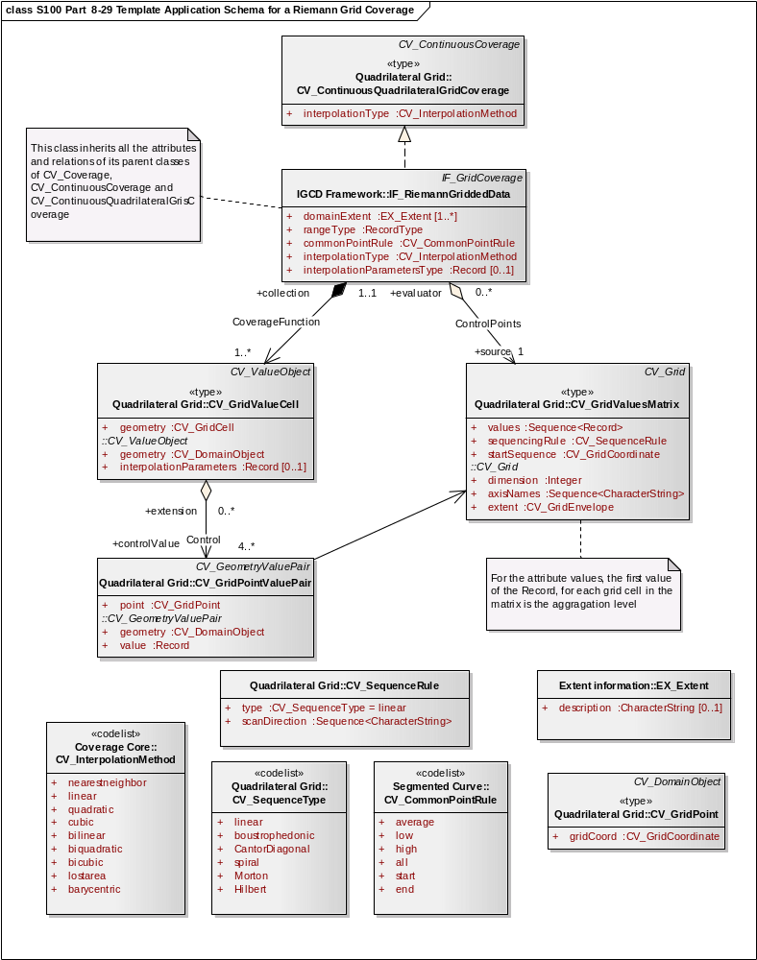
Figure 8-29 - Template Application Schema for a Riemann Grid Coverage

Feature Oriented Image
All gridded data sets are feature oriented, in that a coverage is a subtype of a feature. That is an entire gridded data set can be considered to be a single feature. A feature structure can be applied to gridded data in two different ways. First, a discrete coverage can carry a feature code as an attribute. For example, a coverage corresponding to the postal code system will have discrete values for each postal code, yet still cover the country completely. The only difference in the application schema is a relationship between the discrete coverage and the feature. This is shown in Figure 8-30.

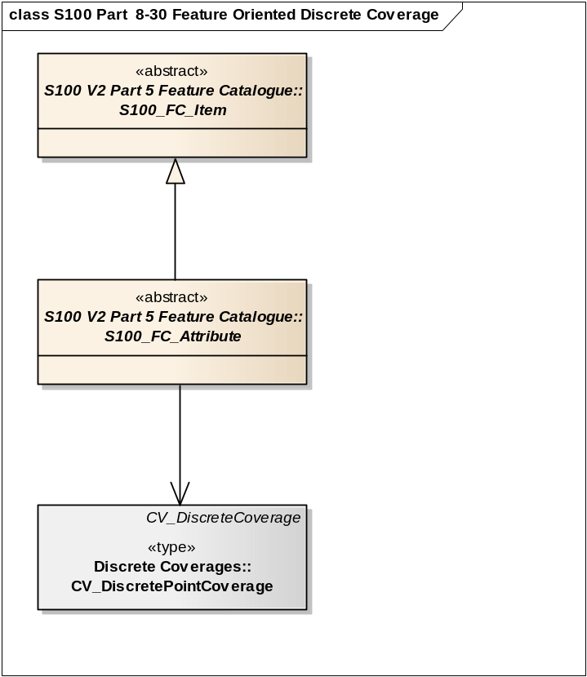

Figure 8-30 - Feature Oriented Discrete Coverage

The second method of establishing a feature structure is to develop a composite data set that contains many separate but adjoining coverages. The coverages may be continuous or discrete. This is very much like the way a "vector" data set is composed where each feature has its own geometry and attributes. In fact vector data may be mixed with coverage data in the same data set. The application schema simply allows multiple instances of features.

Geometric elements such as grids may be shared between multiple features, and features may be related by composition or other relationships as allowed in the general feature model of ISO 19109. A complex feature may include both a continuous grid coverage and vector data such as a polygonal boundary. A feature oriented data set may contain both a continuous coverage of the ocean as collected by sonar, and point and line features corresponding to navigational aids. Topological primitives may relate all of the features. This allows for some interesting and useful structures.

A Raster Nautical Chart may include additional vector data describing the navigational aids, hazards and danger zones, which is not "visible" in that it is not portrayed, but which is active in the use of the Raster Nautical Chart, so a ship can determine whether it is within a danger zone, or perform some other ECDIS-like functions.

See Appendix 8-F for additional information about Feature Oriented Gridded Data.
Appendix 8-A
Abstract Test Suite
(normative)

  - Quadrilateral grid
- Test Purpose: Verify that an application schema instantiates the classes defined in ISO 19123 of CV_Grid, CV_GridPoint, CV_GridCell, CV_GridValuesMatrix, CV_GridPointValuePair, CV_DiscreteGridPointCoverage, or CV_ContinuousGridCoverage, and CV_GridValueCell with their specified attributes, operations, associations and constraints, in the context of the classes S100_GridCoverage, S100_Grid and S100_GridValues as defined in this standard
- Test Method: Inspect the documentation of the application schema or profile.
- Reference: ISO 19123, Clause 8.
- Test Type: Capability.
  - Scanned Image
- Test Purpose: Verify that an application schema for Raster Scan Image satisfies the requirements of A.1; that it includes the metadata elements identified in Table 8-2.
- Test Method: Inspect the documentation of the application schema or profile.
- Reference: ISO 19115, IHO S-61.
- Test Type: Capability.
  - TIN Coverage
- Test Purpose: Verify that an application schema for TIN Coverage instantiates the classes defined in ISO 19123 of CV_TINCoverage, CV_ValueTriangle, and CV_GridPointValuePair with their specified attributes, operations, associations and constraints, in the context of the classes S100_TINCoverage, S100_Triangle and S100_VertexPoint as defined in this standard.
- Test Method: Inspect the documentation of the application schema or profile.
- Reference: ISO 19123
- Test Type: Capability.
  - Point Coverage
- Test Purpose: Verify that an application schema for Point Coverage instantiates the classes defined in ISO 19123 of CV_DiscretePointCoverage, and CV_PointValuePair, with their specified attributes, operations, associations and constraints, in the context of the classes S100_PointCoverage and S100_VertexPoint as defined in this standard.
- Test Method: Inspect the documentation of the application schema or profile.
- Reference: ISO 19123
- Test Type: Capability.

  - Point Set
- Test Purpose: Verify that an application schema for Point Set instantiates the classes defined in ISO 19107 of GM_Point, with its specified attributes, operations, associations and constraints, in the context of the classes S100_PointSet and S100_Point as defined in this standard.
- Test Method: Inspect the documentation of the application schema or profile.
- Reference: ISO 19107
- Test Type: Capability.
  - Variable Cell Size Grid
- Test Purpose: Verify that an application schema for Variable Cell Size instantiates the classes defined in ISO 19123 of CV_Grid, CV_GridPoint, CV_GridCell, CV_GridValuesMatrix, CV_GridPointValuePair, CV_DiscreteGridPointCoverage, or CV_ContinuousGridCoverage, and CV_GridValueCell with their specified attributes, operations, associations and constraints, with the CV_ContinuousCoverage CV_InterpolationMethod attribute set to NearestNeighbour and the CV_GridValuesMatrix CV_SequenceRule attribute set to (x,y) Morton.
- Test Method: Inspect the documentation of the application schema or profile.
- Reference: ISO 19123
- Test Type: Capability.
  - Feature Oriented Image Discrete Coverage
- Test Purpose: Verify that an application schema for Feature Oriented Image that uses a discrete coverage instantiates the classes defined in ISO 19123 of CV_Grid, CV_GridPoint, CV_GridCell, CV_GridValuesMatrix, CV_GridPointValuePair, CV_DiscreteGridPointCoverage, CV_DiscreteCoverage, and CV_GeometryValuePair with their specified attributes, operations, associations and constraints.
- Test Method: Inspect the documentation of the application schema or profile.
- Reference: ISO 19123, 19109
- Test Type: Capability.
  - Feature Oriented Image in a Multi-feature Environment
- Test Purpose: Verify that an application schema instantiates the classes defined in ISO 19123 of CV_Grid, CV_GridPoint, CV_GridCell, CV_GridValuesMatrix, CV_GridPointValuePair, CV_DiscreteGridPointCoverage, or CV_ContinuousGridCoverage, and CV_GridValueCell with their specified attributes, operations, associations and constraints, and that multiple features are permitted with separate CV_Coverages or GM_Objects.
- Test Method: Inspect the documentation of the application schema or profile.
- Reference: ISO 19123, 19109, 19107
- Test Type: Capability

Appendix 8-B
Terminology
(informative)

The terminology used in S-100 aligns with the terminology used in the ISO 19100 suite of standards and it is different to that used in the previous editions of S-57. The previous editions of S-57 used the terms “raster” and “matrix” to address images and data described by organized sets of attribute values. The ISO 19100 suite of standards has a more rigorous definition of terms, but these new terms include much more that is normally thought of as "Raster" or "Matrix" data. Unfortunately current terms in this field have been used with broad overlapping meanings and the terminology can be confusing.

One of the most misused terms is “raster”. Technically the term describes the row by column scanning of a regular rectangular grid, such as the raster scan of a television screen. A raster is a type of a grid. However, often the term is used in a very broad sense to mean most, but not all types of data that cover an area. S-100 now makes use of the term “raster” in its more precise technical sense as a traversal method for a grid of data.

“matrix” is a term that is also used in different ways in different contexts. It is sometimes colloquially used to address all gridded data that corresponds to measurements from non-imaging sensors. But what is an imaging sensor? What is an image? Anything that can be "seen" is thought of as being an image. But a graph of measured data such as elevations, even a two-dimensional graph of data, can be seen. In fact visualization is the purpose of graphing. The term “matrix” also has a mathematical meaning of being an organized set of numbers. The current colloquial meaning of the term “matrix” has been abandoned in this edition of S-100, and the mathematical meaning of an ordered set of numbers is retained as the meaning for the word.

ISO begins defining its terminology by defining a "coverage". In TC211, a coverage is defined as a "function to return one or more feature attribute values for any direct position within its spatiotemporal domain". For a continuous coverage any position in the spatiotemporal domain has a value. A coverage function is basically an interpolation function over a set of grid points or other points covering an area. This makes a coverage the inverse of what is normally thought of as a set of gridded data. Data collected from a sensor creates a values matrix that drives the coverage function. This set of values may be organized in several ways. The simplest is a regular grid, but there may be other organizations of grids such as tiled grids or irregular shaped grids. There may even be grids with variable size cells in multi-dimensions that have been shown to be quite effective in handling hydrographic sounding data. The ISO 19123 standard defines a Grid Value Matrix, TIN Value Triangle, Segmented-Curve Value Curves, and Thiessen Value Polygons as the base elements for the set of data sampled from a sensor. This component of S-100 only needs the concept of a grid value matrix, and does not need to address Segmented Curves, or Thiessen Polygons.

The terms Imagery, Gridded and Coverage data are not mutually exclusive terms. Imagery is a type of Gridded data and Gridded data is a type of Coverage data. Coverage is the broad term. Grid describes one organization of the matrix of data supporting a coverage function. An image is data that may be "viewed".

S-100 needs to use terminology in alignment with ISO and other external standards. However it also needs to recognize the uses of terms in previous editions of S-57. A raster is a grid traversal method. Therefore “Raster Image Data” means data organized as a set of grid value matrix points representing an image. “Raster Image Data” corresponds generally to the term Raster Data as used in S-57 edition 3. Gridded data is all data organized as a set of grid value matrix points. Therefore “Gridded Data” corresponds generally to the term Matrix Data as used in S-57 edition 3.
Appendix 8-C
Quality Model for Imagery and Gridded Data
(informative)

The following is a list of quality elements test procedures from ISO 19129 that addresses imagery and gridded data.

- Top-level classes of the quality-model
General image quality
Visual inspection and evaluation of image geometry
Analytical inspection and evaluation of image geometry
Visual inspection and evaluation of image radiometry
Analytical inspection and evaluation of image radiometry

The following listings are non-exhaustive listings of the subclasses of the quality model.

- Class General image quality
check parameters affecting the quality (data compression etc.)
make test scanning or test imaging

- Class Visual inspection and evaluation of image geometry
check number of channels (black&white, colour, multispectral, etc.)
check edge-matching
check event of blurring
check rectification errors
check “pixel-stretching”
check overlay with vector data (other mapping data, map-frame)
check overlay with other raster or gridded data
identify source of data
inspect documentation of the quality of the sensor or the scanner (calibration data)
inspect documentation of previous processing step (image enhancements)
check resolution of imaged test patterns

- Class Analytical inspection and evaluation of image geometry
check seam lines of mosaics
check colour stability / homogeneity / balance
check grade of illumination of the image (hot spot)
check histogram
check coloured fringes along lines with high contrast

- Class Visual inspection and evaluation of image radiometry
calculate geometric residuals at checkpoints in 2D and/or in 3D
calculate residuals in range at checkpoints

- Class Analytical inspection and evaluation of image radiometry
calculate contrast
calculate brightness
Appendix 8-D
Metadata
(informative)

Metadata for S-100 is taken where possible from the ISO 19115 Metadata standard to ensure a high level of compatibility with other standards based on the same metadata standard. This metadata has been organized into a number of packages. The following is a list of the packages defined in ISO 19115.

Relationship between packages of metadata and metadata entities
Package | Entity
Metadata entity set information | MD_Metadata
Identification information | MD_Identification
Constraint information | MD_Constraints
Data quality information | DQ_DataQuality
Maintenance information | MD_MaintenanceInformation
Spatial representation information | MD_SpatialRepresentation
Reference system information | MD_ReferenceSystem
Content information | MD_ContentInformation
Portrayal catalogue information | MD_PortrayalCatalogueReference
Distribution information | MD_Distribution
Metadata extension information | MD_MetadataExtensionInformation
Application schema information | MD_ApplicationSchemaInformation
Extent information | EX_Extent
Citation and responsible party information | CI_Citation  CI_ResponsibleParty

ISO TC211 has also completed ISO 19115-2 Geographic information - Metadata - Part 2: Extensions for imagery and gridded data. It contains additional packages for MI_AcquisitionInformation, Lineage (Source and Process), Quality result for Coverage (QE_CoverageDescription) and usability (QE_Usability) that are relevant for the description of Imagery and Gridded data in S100.
The MI_AcquisitionInformation package provides details specific to the acquisition of imagery and gridded data. It contains:
- MI_Instrument, designations of the measuring instruments used to acquire the data;
- MI_Operation, designations of the overall data gathering program to which the data contribute;
- MI_Platform, designations of the platform from which the data were taken;
- MI_Objective, the characteristics and geometry of the intended object to be observed;
- MI_Requirement, the user requirements used to derive the acquisition plan;
- MI_Plan, the acquisition plan that was implemented to acquire the data.
- MI_Event, describes a significant event that occurred during data acquisition. An event can be associated with an operation, objective, or platform pass, and
- MI_PlatformPass, identifies a particular pass made by the platform during data acquisition. A platform pass is used to provide supporting identifying information for an event and for data acquisition of a particular objective.

The additional classes to address the sources and production processes of particular importance for imagery and gridded data are:
- QE_CoverageResult is a specified subclass of DQ_Result and aggregates information required to report data quality for a coverage;
- QE_Usability is a specified subclass of DQ_Element used to provide user specific quality information about a dataset’s suitability for a particular application;
- LE_ProcessStep is a specified subclass of LI_ProcessStep and contains additional information on the history of the algorithms used and processing performed to produce the data. It includes a description of;
      - LE_Processing, which describes the procedure by which the algorithm was applied to generate the data from the source data.;
      - LE_ProcessStepReport which identifies external information describing the processing of the data;
      - LE_Source,which describes the output of a process step.

  - Metadata entity set information (MD_Metadata) from ISO 19115
The MD_Metadata entity is an aggregate of the following entities (which are further explained in the following subclauses):

- Identification information (MD_Identification)
Identification information contains information to uniquely identify the data. It includes information about the citation for the resource, an abstract, the purpose, credit, the status and points of contact. The MD_Identification entity is mandatory. It contains mandatory, conditional, and optional elements. MD_Identification is an aggregate of the following entities:
- MD_Format, format of the data
- MD_BrowseGraphic, graphic overview of the data
- MD_Usage, specific uses of the data
- MD_Constraints, constraints placed on the resource
- MD_Keywords, keywords describing the resource
- MD_MaintenanceInformation, how often the data is scheduled to be updated and the scope of the update

- Constraint information (MD_Constraints)
This package contains information concerning the restrictions placed on data. The MD_Constraints entity is optional and may be specified as MD_LegalConstraints and/or MD_SecurityConstraints. The otherConstraint element of MD_LegalConstraints shall be non-zero (used) only if accessConstraints and/or useConstraints elements have a value of “otherRestrictions”, which is found in the MD_Restriction enumeration.

- Data quality information (DQ_DataQuality)
This package contains a general assessment of the quality of the dataset. The DQ_DataQuality entity is optional and contains the scope of the quality assessment. DQ_DataQuality is an aggregate of LI_Lineage and DQ_Element. DQ_Element can be specified as DQ_Completeness, DQ_LogicalConsistency, DQ_PositionalAccuracy, DQ_ThematicAccuracy and DQ_TemporalAccuracy. Those five entities represent Elements of data quality and can be further subclassed to the sub-Elements of data quality. Users may add additional elements and sub-elements of data quality by sub-classing DQ_Element or the appropriate sub-element.
This package also contains information about the sources and production processes used in producing a dataset. The LI_Lineage entity is optional and contains a statement about the lineage. LI_Lineage is an aggregate of LI_ProcessStep and LI_Source. The “report” and “lineage” roles of DQ_DataQuality are mandatory if DQ_DataQuality.scope.DQ_Scope.level has a value of “dataset”. The “levelDescription” element of DQ_Scope is mandatory if the “level” element of DQ_Scope does not have a value of “dataset” or “series”. The "statement" element of LI_Lineage is mandatory if DQ_DataQuality.scope.DQ_Scope.level has a value of "dataset" or "series" and the LI_Lineage roles of "source" and "processStep" are not documented.
The “source” role of LI_Lineage is mandatory if the ”statement” element and the ”processStep” role of LI_Lineage are not documented. The “processStep” role of LI_Lineage is mandatory if the ”statement” element and the ”source” role of LI_Lineage are not documented. Either the “description” or “sourceExtent” element of LI_Source must be documented.

- Maintenance information (MD_MaintenanceInformation)
This package contains information about the scope and frequency of updating data. The MD_MaintenanceInformation entity is optional and contains mandatory and optional metadata elements.

- Spatial representation information (MD_SpatialRepresentation)
This package contains information concerning the mechanisms used to represent spatial information in a dataset. The MD_SpatialRepresentation entity is optional and can be specified as MD_GridSpatialRepresentation and MD_VectorSpatialRepresentation. Each of the specified entities contains mandatory and optional metadata elements. When further description is necessary, MD_GridSpatialRepresentation may be specified as MD_Georectified and/or MD_Georeferenceable. Metadata for Spatial data representation are derived from ISO 19107.

- Reference system information (MD_ReferenceSystem)
This package contains the description of the spatial and temporal reference system(s) used in a dataset. MD_ReferenceSystem contains an element to identify the reference system used. MD_ReferenceSystem may be subclassed as MD_CRS, which is an aggregate of MD_ProjectionParameters and MD_EllipsoidParameters. MD_ProjectionParameters is an aggregate of MD_ObliqueLineAzimuth and MD_ObliqueLinePoint. MD_ReferenceSystem is derived from RS_ReferenceSystem, which can be specified as SC_CRS, SI_SpatialReferenceSystemUsingGeographicIdentifiers and TM_ReferenceSystem. Metadata for Reference system information are derived from ISO 19108, ISO 19111 and ISO 19112.

- Content information (MD_ContentInformation)
This package contains information identifying the feature catalogue used (MD_FeatureCatalogueDescription) and/or information describing the content of a coverage dataset (MD_CoverageDescription). Both description entities are subclasses of the MD_ContentInformation entity. MD_CoverageDescription may be subclassed as MD_ImageDescription, and is an aggregate of MD_RangeDimension. MD_RangeDimension may additionally be subclassed as MD_Band.

- Portrayal catalogue information (MD_PortrayalCatalogueReference)
This package contains information identifying the portrayal catalogue used. It consists of the optional entity MD_PortrayalCatalogueReference. This entity contains the mandatory element used to specify which portrayal catalogue is used by the dataset.

- Distribution information (MD_Distribution)
This package contains information about the distributor of, and options for obtaining, a resource. It contains the optional MD_Distribution entity. MD_Distribution is an aggregate of the options for the digital distribution of a dataset (MD_DigitalTransferOptions), identification of the distributor (MD_Distributor) and the format of the distribution (MD_Format), which contain mandatory and optional elements. MD_DigitalTransferOptions contains the medium used for the distribution (MD_Medium) of a dataset, and is an aggregate of MD_DigitalTransferOptions. MD_Distributor is an aggregate of the process for ordering a distribution (MD_StandardOrderProcess).

The “distributionFormat” role of MD_Distribution is mandatory if the “distributorFormat” role of MD_Distributor is not documented. The “distributorFormat” role of MD_Distributor is mandatory if the “distributionFormat” role of MD_Distribution is not documented.

- Metadata extension information (MD_MetadataExtensionInformation)
This package contains information about user specified extensions. It contains the optional MD_MetadataExtensionInformation entity. MD_MetadataExtensionInformation is an aggregate of information describing the extended metadata elements (MD_ExtendedElementInformation).

- Application schema information (MD_ApplicationSchemaInformation)
This package contains information about the application schema used to build a dataset. It contains the optional entity MD_ApplicationSchemaInformation which is an aggregate of MD_SpatialAttributeSupplement, which is an aggregate of MD_FeatureTypeList. The entities contain mandatory and optional elements.

Metadata extensions for Imagery from ISO 19115-2. The work on ISO 19115-2 is still (June 2009) in the development phase. However the general types of extensions have been identified. The following are examples of those extensions.
MI_AcquisitionInformation a new class in the Data Identification Package
- planningPoints
- instrumentIdentification
- platformIdentification
- missionIdentification
MD_ImageDescription
- aerotriangulationReference
- localElevationAngle
- localAzimuthAngle
- relativeAzimuth
- platformDescending
- nadir
Other metadata will derive from the work on ISO 19130 Sensor Models, and any input from IHO. In particular there is a need for input on metadata about hydrographic sounding sensors.
Appendix 8-E
Portrayal of Imagery and Gridded Data
(informative)
  - Colour
Imagery and gridded data makes use of RGB or colour coding for the representation of pixel values. When digitizing a synthetic image such as a map or chart the use of a colour map can produce significant advantages in the amount of data, which needs to be communicated. If only a very few colours are used in a printed product, then only that number of colour map entries are required, and subsequently only a few bits are required per pixel to address in the colour map. For example, if a chart used only seven inks when it was originally printed, and if it is possible to distinguish these as seven distinct colours, then a colour map could be constructed which specifies each of these seven colours in terms of their exact colour values. Only 3 bits per pixel would be required to be indexed in the colour map.

  - Color Systems
Useful systems for image coding are linear RGB (Red Green Blue), nonlinear RGB, nonlinear CMY (Cyan Magenta Yellow), nonlinear CMYK (Cyan Magenta Yellow Black), and derivatives of nonlinear RGB such as YCrCb (Luminosity and Colour components) and HSV (Hue Saturation Value). Numerical values of hue and saturation are not useful in colour image coding, however they are extremely important for colour interpolation and colour tiling. Direct acquisition of luminance requires use of a very specific spectral weighting. However, luminance can also be computed as a weighted sum of red, green and blue components. If three sources appear red, green and blue, and have the same radiance in the visible spectrum, then the green will appear the brightest of the three because the luminous efficiency function peaks in the green region of the spectrum. The red will appear less bright, and the blue will be the darkest of the three.

As a consequence of the luminous efficiency function, all saturated blue colours are quite dark and all saturated yellows are quite light. If luminance is computed from red, green and blue, the coefficients will be a function of the particular red, green and blue spectral weighting functions employed, but the green coefficient will be quite large, the red will have an intermediate value, and the blue coefficient will be the smallest of the three.

Of the aforementioned colour systems, the three best suited for object related raster are RGB, HSV, and YCrCb. RGB separates the Red, Green and Blue components of a given colour. HSV separates a colour into its Hue, Saturation and Value. Saturation is the colourfulness of an area judged in proportion to its brightness. Saturation runs from neutral grey through pastel to saturated colours. Hue is the attribute of a visual sensation according to which an area appears to be similar to one of the perceived colours, red, yellow, green and blue, or a combination of two of them. Value is the same as Intensity, a measure over some interval of the electromagnetic spectrum of the flow of power. Value, in this case, is the linear-light measure. YCrCb separates the Luminosity from the colour components. Luminosity, or Brightness, is the attribute of a visual sensation according to which an area appears to emit more or less light. The two colour components are referred to as the Chrominance (Chrominance Red and Chrominance Blue). Chrominance is calculated as the difference between a colour and a reference white at the same luminance.

HSV is the best for interpolation due to its consistent scalability. YCrCb has better capabilities in compression.

RGB is not the best for aggregated data compression due to its discontinuity within the colour spectrum range. HSV and YCrCb have better compression capability due to their being continuous and consistent in the colour spectrum. YCrCb has better compression, marginally, since it allows the colour elements Cr and Cb to be separate from luminosity Y. Compression can then operate on the basis of colour elements Cr and Cb rather than being biased by luminosity.

All three colour systems have their individual advantages. RGB as the storage mechanism since most systems are standardized to it. HSV as the mechanism for interpolation and compression due to its consistent scalability. YCrCb can also be used for a compression mechanism since it allows colour elements to be separated from luminosity, allowing a higher compaction ratio, however that impacts interpolation. The HSV value is a percentage value that is spread over the ranges evenly with respect to the individual respective HSV and RGB values that is used as a tolerance for data aggregation.

These three colour systems (RGB, HSV, YCrCb) can be incorporated within the same architecture in separate context. As above, the reasons for this are that RGB as the storage mechanism since most systems have standardized to it, HSV as the mechanism for interpolation due to its consistent scalability, YCrCb for the mechanism compression since it allows colour elements to be separated from luminosity.

Colour codes are stored in a colour lookup table along with their CIE (x, y, Y) reference and RGB intensity values. Both RGB and CIE are different colour systems by which colours may be specified. RGB is a simple system consisting of the intensity of each of the three primary colours Red, Green, and Blue. Note, that these are additive primary colours where Green and Blue make Yellow, that is, the mixing of lights. For subtractive primary colours, such as the mixing of paints, the primary colours are Red, Yellow and Blue, and the mixing of Yellow and Blue make Green. As long as the light frequencies corresponding to Red, Green and Blue are specified, then any colour that can be produced by the mixing of these base colours can be specified in terms of the intensity of the RGB components. The exact frequencies for Red, Green and Blue, the phosphor colours for a CRT, are specified in the Television Standards CCIR Com 11 R 608.

The CIE colour system is a separate colour system based on colourimetric principles. It does not rely on three basis colour primaries, but rather on a two-dimension colour space, in which all colours, even those that cannot be represented on paper or on a CRT, can be described.
The example given above of the selection of only seven colours based on the original inks used on a map or chart is in most cases impractical, because often inks are mixed and print masks are used to represent shades of a colour, such as a light blue being composed of alternate white and blue pixels. Nevertheless in a real map or chart the number of colours is usually limited to under 256 which can be represented in 8 bits. If a colour is a known mixture of two other colour codes, then the proportions of the two or more defined colours included in the mix should be defined in the colour table. For example if Colour 5 in the colour table is a mixture of 33% of Colour 3 and 67% of Colour 1 then these proportions should be defined. The purpose of this is to allow easy modification of the colours for display purposes.

  - Attribute Colour Portrayal
Colour Ramps – Colour Ramps are continuous colour spectra ranging from a specified start and end point. They can cover the complete visible spectrum or a limited component of it. As well, a Colour Ramp can be in grey-scale. Although theoretically continuous, the application of a Colour Ramp necessitates that the portrayal be a discrete representation of the given spectrum. Large or small ranges of data can be compressed or stretched in the process of ramping the attribute values. As well, start and end points can be selected on a given spectrum to aid in the best portrayal of data with limited dynamic range.

Colour Banding – Colour Banding is also referred to as Colour Tables. It is a list or table containing discrete colour values and attribute value ranges. For every range of an attribute’s value (e.g. 10-20) a specific colour is assigned (e.g. red, or R=255 G=0 B=0). Most often the series of colour assignments follows a progressive path which discretely mimics a ramped colour spectrum, but it is not necessary – there is no need for any progressive pattern.
Colour Tables can be chosen or designed to best portray certain types of data or to highlight specific aspects.

Object Colouring – Colour can also be assigned by object or object type. In this manner, within a given attribute if certain feature types have been made into objects, they can be coloured based wholly on their identity. In this manner, boulders (the object ‘boulder’) could be assigned the colour green (R=0 G=255 B=0), while bridge objects could be assigned some other colour (e.g. R=123 G=55 B=234). This is similar to the Colour Table approach, except that colours are assigned to individual objects and not an attribute value or range. As well, several attributes can be used to define a given object and thus colouring is based indirectly on multiple attributes.

Within a given visualization, data can be portrayed using any of these approaches. As well, combinations can be used. As an example, bathymetric depth data could be coloured using a Colour Ramp of the blue spectrum, while objectified boulders are assigned an object colour and portrayed as yellow (R=0 G=255 B=255).
Appendix 8-F
Feature Oriented Images
(informative)

The Spatial Object in the S-100 model and in the ISO model can represent either Vector data or Imagery, Gridded or Coverage data. Both make reference to an externally defined Spatial Referencing System. Also both are feature oriented.

Most people do not think of Imagery, Gridded or Coverage data as being feature oriented. At the minimum an image or a set of gridded measurements or a TIN coverage can be considered as a single feature, so in essence such data is feature oriented. But this is the minimum case. It is possible to include in an imagery, gridded or coverage data set a data structure that could group pixels to identify features. For example an attribute could be included with each pixel that carried a feature ID number. This would allow one to identify certain features as being a particular feature type. In an image data set corresponding to a scanned paper chart, one could mark sets of pixels as representing various hydrographic features. There are other more efficient methods of carrying such feature ID attribute data for an image than adding bits to each pixel. There is no obligation to build such sophisticated feature oriented imagery data sets, but both S-100 and the ISO standards allow them to be built if needed. This can be very important for the fusion of bathymetric sensor data represented as an image together with vector chart data.

This appendix discusses the utility of feature oriented images and gives examples. The structures to support feature oriented images are very simple and are part of the application. It is not obvious that a single reference within the data model allows for an entire capability, so this informative appendix illustrates how that capability can be implemented and used.

All gridded data sets are feature oriented, in that a coverage is a subtype of a feature. That is, an entire gridded data set can be considered to be a single feature. A feature structure can be applied to gridded data in two different ways. First, a discrete coverage can carry a feature code as an attribute. For example, a coverage corresponding to the postal code system will have discrete values for each postal code, yet still cover the country completely. The only difference in the application schema is a relationship between the discrete coverage and the feature. This is shown in Figure 8-F 1.

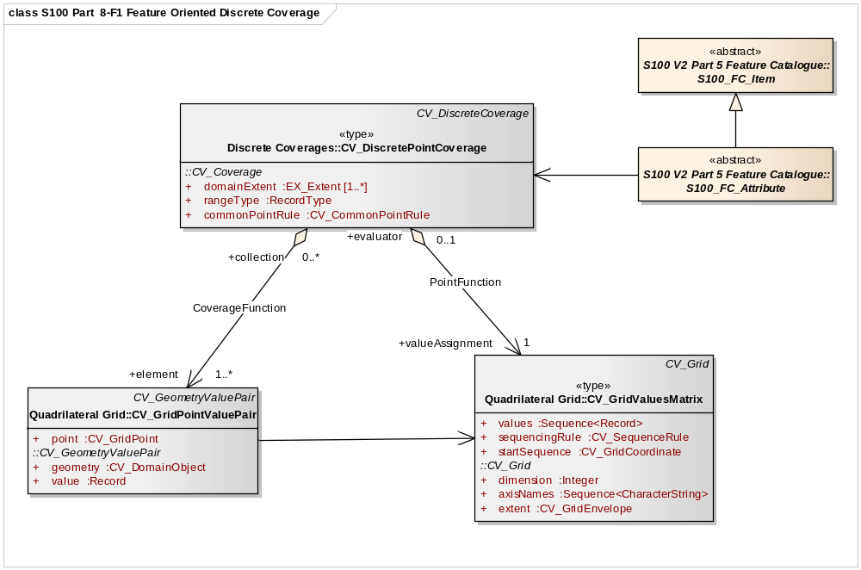
Figure 8-F-1 – Feature Oriented Discrete Coverage

The model shown if Figure 8-F-2 illustrates the collocation of two grids, supported by one grid value matrix to achieve the assignment of feature ID to specific cells. The discrete coverage allows for the assignment of feature codes to Grid Value Matrix entities and the continuous coverage allows one to handle the image.

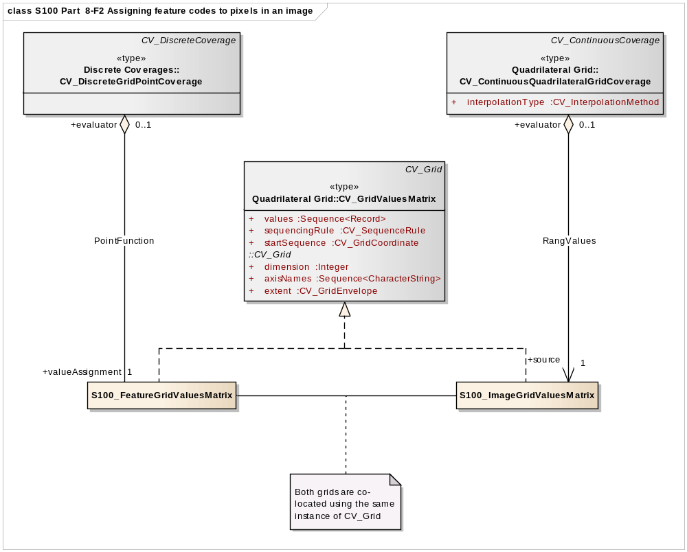
Figure 8-F-2 – Assigning feature codes to pixels in an image.

The second method of establishing a feature structure is to develop a composite data set that contains many separate but adjoining coverages. The coverages may be continuous or discrete. This is very much like the way a "vector" data set is composed where each feature has its own geometry and attributes. In fact vector data may be mixed with coverage data in the same data set. The application schema simply allows multiple instances of features.

Geometric elements such as grids may be shared between multiple features, and features may be related by composition or other relationships as allowed in the general feature model of ISO 19109. A complex feature may include both a continuous grid coverage and vector data such as a polygonal boundary. A feature oriented data set may contain both a continuous coverage of the ocean as collected by sonar, and point and line features corresponding to navigational aids. Topological primitives may relate all of the features. This allows for some interesting and useful structures. For example, a scanned paper map represented as a gridded data set may include additional vector data describing the roads and other features on the scanned map, which is not "visible" in that it is not portrayed, but which is active in that a user might query the name of a feature or traverse along a road on what would appear to be a gridded data set.

There is a commonality between the text in portions of this standard and in the ISO standard 19129 because sections of this document have been contributed to ISO as input in the development of ISO 19129 and have thus been incorporated into the ISO document.

